SOLANO PERMITTEES
Green Stormwater Infrastructure
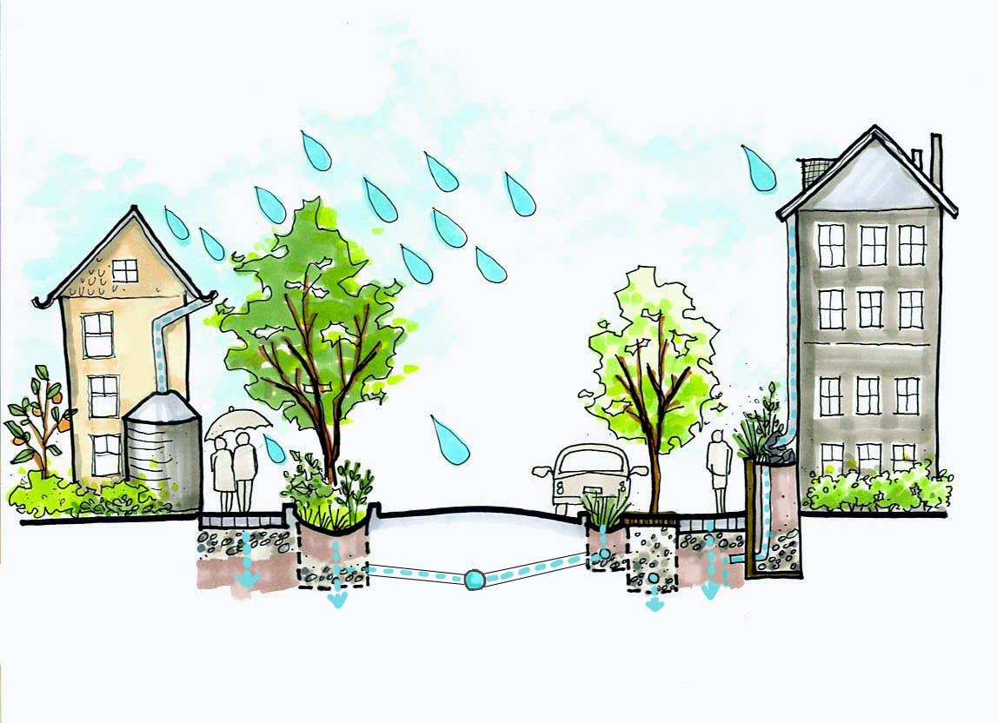
PLAN

PUBLIC REVIEW DRAFT
DRAFT July 2019


In compliance with Provision C.3.j.i.(1) of Order R2-2015-0049

Table of Contents
1 Executive Summary 5
2 Introduction and Overview 6
2.1 Regulatory Mandate 6
2.2 Objectives and Vision 8
3 City of Vallejo Description and Background 9
3.1 Vallejo Planning Context 9
3.2 Watersheds and Storm Drainage Infrastructure 10
4 Green Stormwater Infrastructure Targets 13
4.1 Redevelopment and Land Use Conversion 14
4.2 Specific Green Stormwater Infrastructure Projects 18
4.3 Projected Load Reductions 21
5 Project Identification, Prioritization, and Mapping 26
5.1 Tool for Project Identification and Prioritization 26
5.2 Tool for Project Ranking and Prioritization 28
6 Early Implementation Projects 30
6.1 Review of Capital Improvement Projects 30
6.2 Workplan for Completion 30
7 Tracking and Mapping Public and Private Projects Over Time 34
7.1 Tools and Process 34
8 Design Guidelines and Specifications 36
8.1 Guidelines for Streetscape and Project Design 37
8.2 Specifications and Typical Design Details 37
8.3 Sizing Requirements 38
9 Funding Options 39
9.1 Funding Strategies Developed Regionally 39
9.2 Local Funding Strategies 45
10 Integration with City Plans & Documents 49
10.1 Related Regional and Countywide Plans and Planning Documents 49
10.2 Existing City Plans that Support GSI 50
10.3 Workplan for Future Integration of GSI Language into City Plans 50
11 Outreach and Education 52
11.1 Interdepartmental Meetings and Trainings 52
11.2 Public Outreach and Education 52
12 Policies, Ordinances, and Legal Mechanisms 53
12.1 Integrated Planning 53
12.2 Align Stormwater with Climate Resiliency 54
12.3 Increase Stormwater Management Requirements 55
12.4 Training and Certification 55
12.5 Create Incentives for GSI 55
12.6 Change Agency Business Practices 56
12.7 Participate in Regional Partnerships to Support GSI 57
12.8 Address Social Needs 57
13 Adaptive Management 58
14 Appendices 59
Appendix A - BASMAA: “Guidance for Identifying Green Infrastructure Potential in Municipal Capital Improvement Projects” 59
Appendix B – Solano Permittees’ Green Stormwater Infrastructure Design Guidebook 60
Appendix C – Funding Options Summary Tables 61
Appendix D – GSI Integration with City Plans and Documents 64
Appendix E - GSI RAA Modeling Report 74

Figures
Figure 3-1. Solano Permittee subwatershed boundaries 10
Figure 4-1. Predicted Redevelopment and Land Use Conversion in Vallejo 16
Figure 4-2. Existing green stormwater infrastructure projects and green stormwater infrastructure projects proposed for 2020, 2030, and 20 19
Figure 4-3. Solano Permittees proportional contribution by 2040 of land use changes, New Development/Redevelopment parcels, and combined Parcel LID, dBMPs, and cBMPs to overall reductions from Green Stormwater Infrastructure. 24
Figure 5-1. High priority parcels and road segments for GSI redevelopment 27

Tables
Table 4-1. Impervious area treated forecasts for GSI on parcels planned for New Development or Redevelopment 17
Table 4-2. Impervious area treated forecasts for specific GSI 20
Table 4-3. Estimated Cumulative PCB Reductions from Green Stormwater Infrastructure 22
Table 4-4. Estimated Cumulative Mercury Reductions from Green Stormwater Infrastructure 23
Table 4-5. Predicted compliance with 2020 and 2040 PCB and Mercury pollutant load reduction targets for Green Stormwater Infrastructure. 25
Table 5-1. Example multi-benefits and metrics to prioritize individual stormwater projects relative to each other using a Project Multi-Benefits Assessment. 29
Table 6-1. Public and private projects with green stormwater infrastructure potential identified for future implementation in 2020, 2030, and 2040, along with their pollutant removal potential, status, and planning level capital and maintenance costs. For future scenarios, estimated PCB and mercury reductions are after land use changes have already been applied in the model, so that these reductions only reflect a small portion of the total redevelopment reductions. 31
Table 6-2. Planning level project information used to inform cost estimation. 32
Table 9-1. Grant and loan monies that may be used to fund projects that include both GSI and transportation improvements 41
Table 10-1. City Plans and Documents and Status of GSI Integration 51

Acronyms
ABAG | Association of Bay Area Governments
BASMAA | Bay Area Stormwater Management Agencies Association
Caltrans | California Department of Transportation
cBMP | Centralized Best Management Practice
CIP | Capital Improvement Project
C3 | Refers to Provision C3 in the MRP to address stormwater runoff pollutant discharges and increased flows from New Development and Redevelopment using source control, site design, and stormwater treatment measures.
DAC | Disadvantaged Community
dBMP | Decentralized Best Management Practice
FSSD | Fairfield Suisun Sewer District
GI | Green Infrastructure
GIS | Geographic Information System
GSI | Green Stormwater Infrastructure
IRWMP | Integrated Regional Water Management Plan
LID | Low Impact Development
MRP | Municipal Regional Stormwater Permit
MTC | Metropolitan Transportation Commission
NPDES | National Pollutant Discharge Elimination System
PCBs | Polychlorinated Biphenyls
RAA | Reasonable Assurance Analysis
ROW | Right-of-Way
SFEI | San Francisco Estuary Institute
TMDL | Total Maximum Daily Load
URMP | Urban Runoff Management Program
VFWD | Vallejo Flood and Wastewater District
WLA | Waste Load Allocation

Executive Summary
The purpose of the City of Vallejo’s Green Stormwater Infrastructure (GSI) Plan is to describe how the City will gradually integrate GSI features into its urban landscape over several decades, with a particular focus on retrofit and redevelopment projects. The City, as with other municipalities and agencies in the Bay Area, is subject to the requirements of the California Regional Water Quality Control Board for the San Francisco Bay Region’s (RWQCB’s) Municipal Regional Stormwater Permit (MRP), which became effective on January 1, 2016. A section of the MRP requires Permittees to develop and implement long-term GSI Plans for the inclusion of GSI measures into storm drain infrastructure on public and private property and in the right-of-way, including streets, roads, parking lots, and alleys. The GSI Plan must demonstrate the City’s long-term commitment to GSI implementation to reduce pollutants of concern, in particular PCBs and mercury, discharged to local waterways (per MRP requirements). This document serves to meet the MRP requirement and outlines how the City aims to transform its traditional stormwater conveyance and drainage system over years to come.

Introduction and Overview

Regulatory Mandate
The City of Vallejo is one of 76 local government entities subject to the requirements of the California Regional Water Quality Control Board for the San Francisco Bay Region’s (RWQCB’s) Municipal Regional Stormwater Permit (MRP). The MRP was last reissued in November 2015. The MRP mandates implementation of a comprehensive program of stormwater control measures and actions designed to limit contributions of urban runoff pollutants to San Francisco Bay.
MRP Provision C.3.j.i. requires the City of Vallejo to prepare a Green Stormwater Infrastructure Plan, to be submitted with its Annual Report to the RWQCB due September 30, 2019.
“Green Infrastructure” (GI), also known as “Green Stormwater Infrastructure” (GSI), refers to the construction and retrofit of storm drainage to reduce runoff volumes, disperse runoff to vegetated areas, harvest and use runoff where feasible, promote infiltration and evapotranspiration, and use bioretention and other natural systems to detain and treat runoff before it reaches our creeks and Bay. Green Stormwater Infrastructure facilities include, but are not limited to, bioretention facilities or “rain gardens”, pervious pavement, infiltration features, and rainwater harvesting systems. Green stormwater infrastructure can be incorporated into construction on new and previously developed parcels, as well as new and rebuilt streets, roads, and other infrastructure within the public right-of-way.
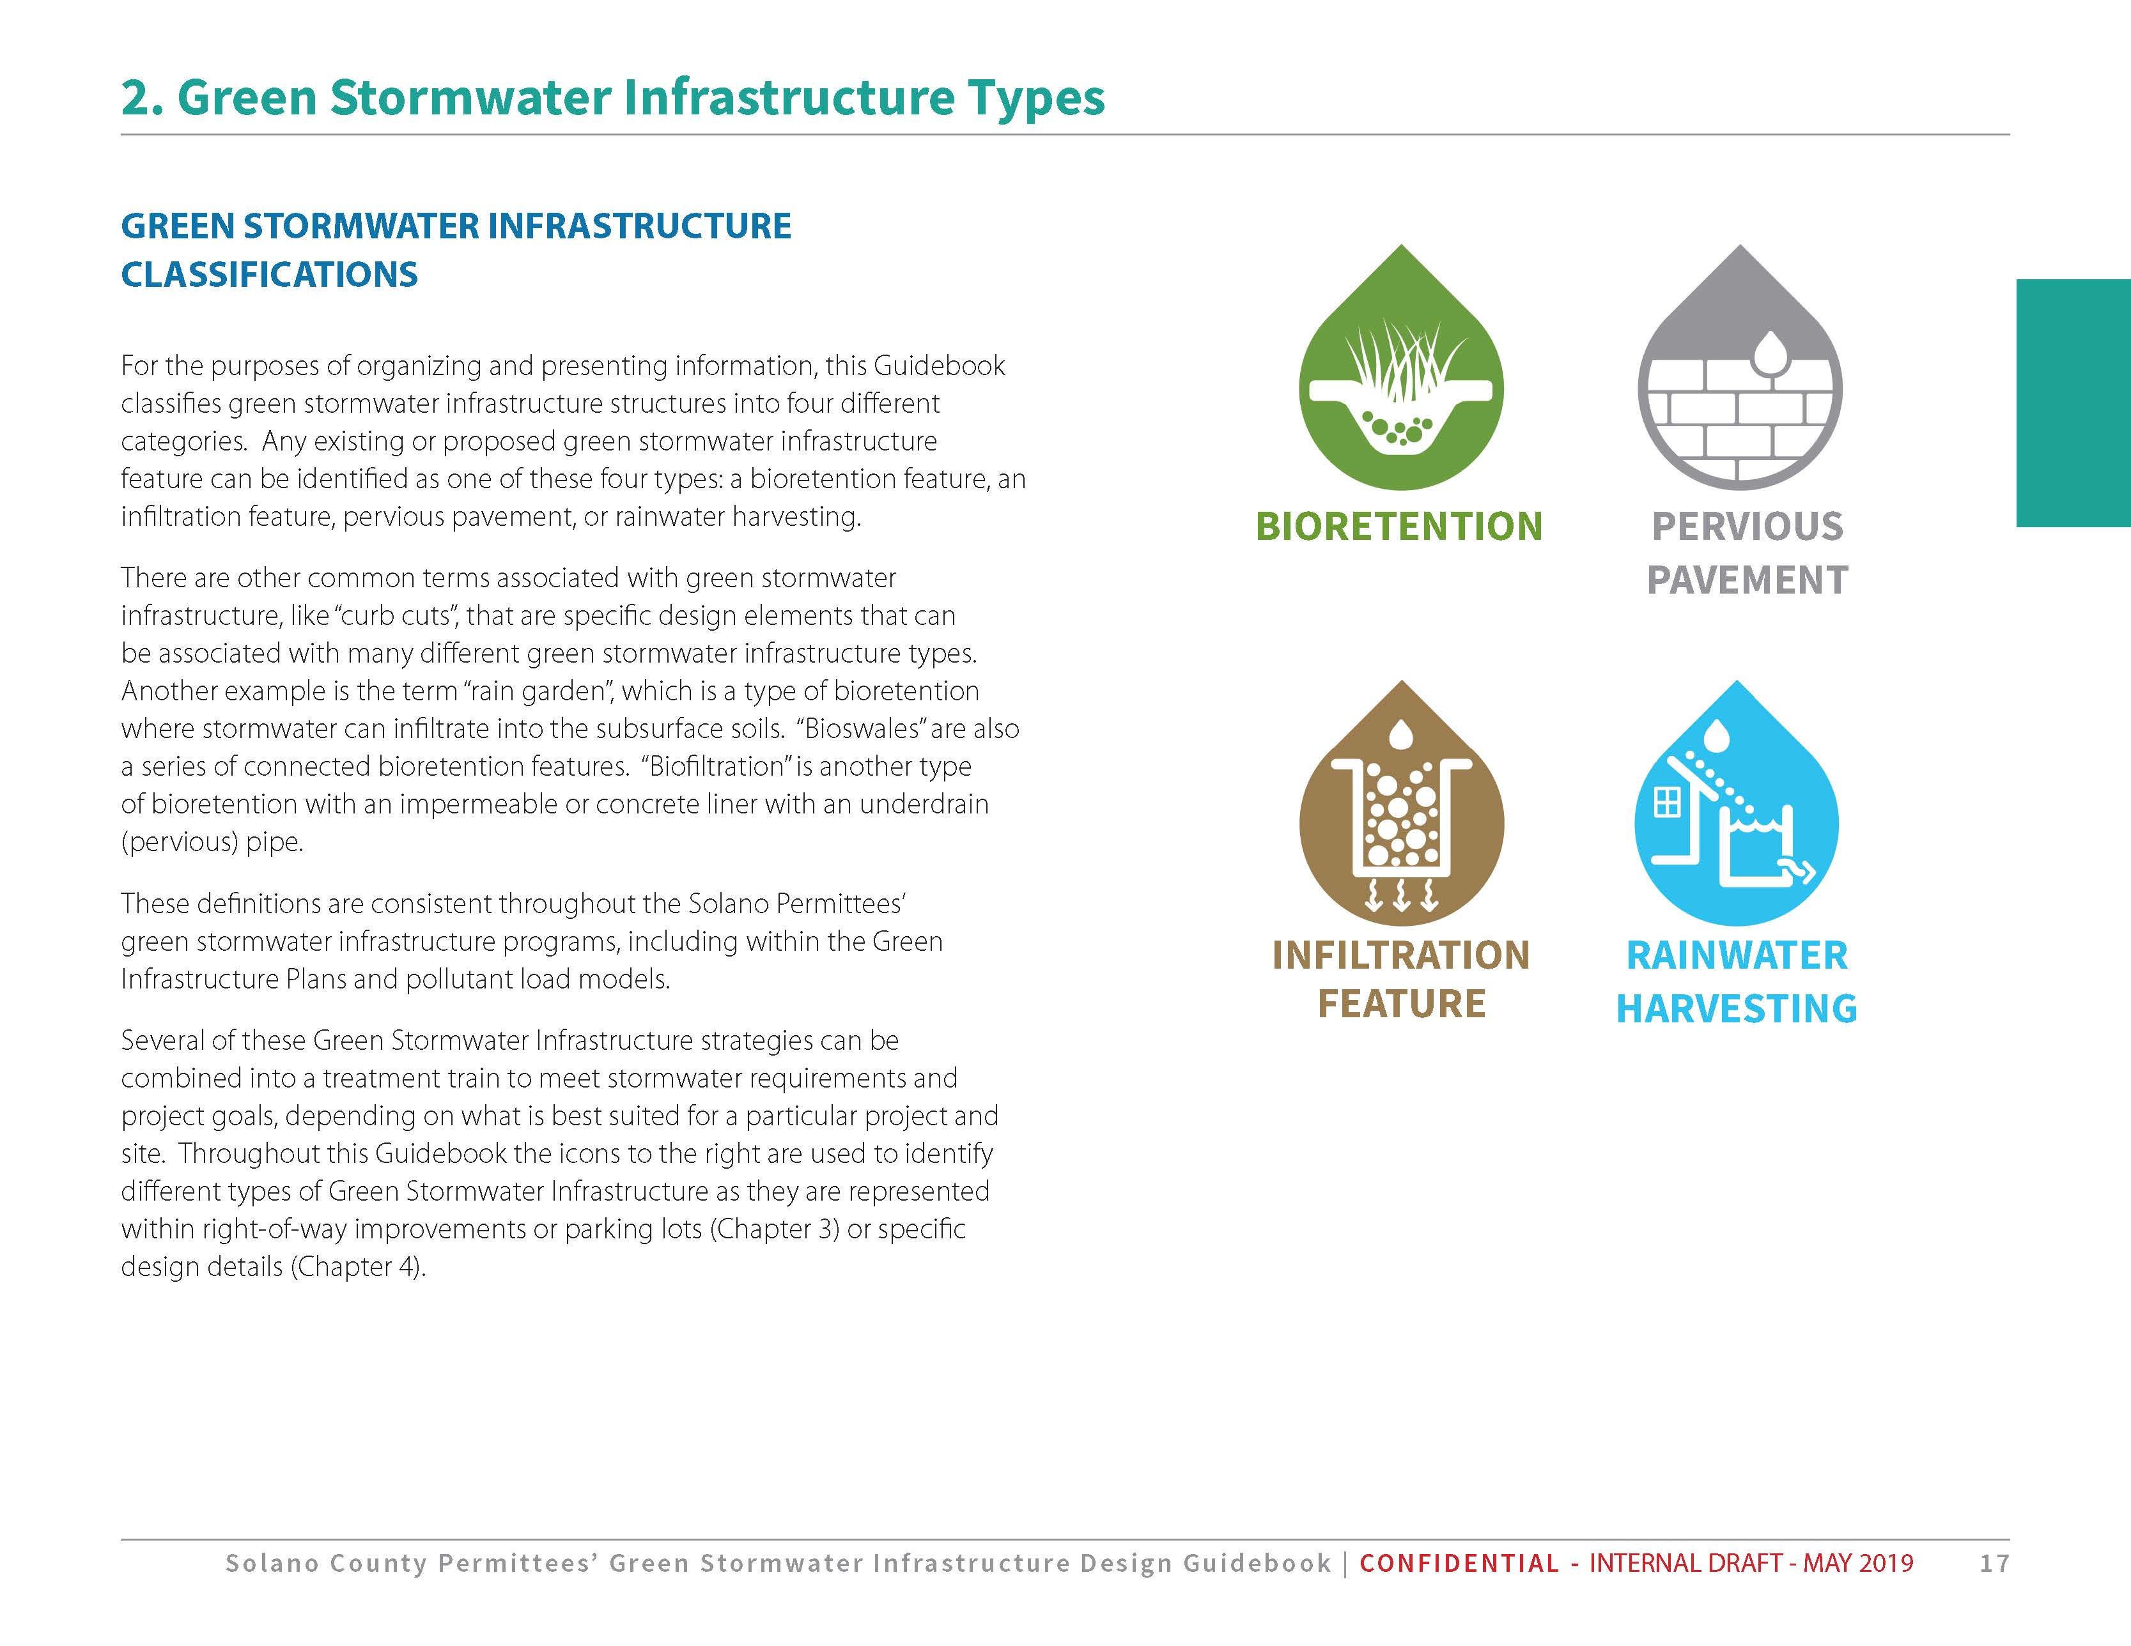
Water quality in San Francisco Bay is impaired by mercury and by polychlorinated biphenyls (PCBs). Sources of these pollutants include urban stormwater. By reducing and treating stormwater flows, green stormwater infrastructure reduces the quantity of these pollutants entering the Bay and will hasten the Bay’s recovery.
Provisions C.11 and C.12 in the MRP require Solano County Permittees (City of Vallejo, City of Fairfield and City of Suisun City) to reduce estimated PCBs loading by 8 grams/year and estimated mercury loading by 2 grams/year using green stormwater infrastructure by June 30, 2020. Regionally, Permittees must also project the load reductions achieved via green stormwater infrastructure by 2020, 2030, and 2040, showing that collectively, reductions will amount to 3 kg/year PCBs and 10 kg/year mercury by 2040. Of these regional 2040 reduction targets, the Solano Permittees are responsible for reductions of approximately 110 grams/year PCBs and 47 grams/year mercury.

Further Background on Mercury and PCBs in San Francisco Bay
The MRP pollutant-load reduction requirements are driven by Total Maximum Daily Load (TMDL) requirements adopted by the RWQCB for mercury (Resolution No. R2-2004-0082 and R2-2005-0060) and PCBs (Resolution No. R2-2008-0012). Each TMDL allocates allowable annual loads to San Francisco Bay from identified sources, including from urban stormwater.
The mercury TMDL addresses two water quality objectives. The first, established to protect people who consume Bay fish, applies to fish large enough to be consumed by humans. The objective is 0.2 milligrams (mg) of mercury per kilogram (kg) of fish tissue. The second objective, established to protect aquatic organisms and wildlife, applies to small fish commonly consumed by the California least tern, an endangered species. This objective is 0.03 mg mercury per kg fish. To achieve the human health and wildlife fish tissue and bird egg monitoring targets and to attain water quality standards, the Bay-wide suspended sediment mercury concentration target is 0.2 mg mercury per kg dry sediment.
The PCBs TMDL was developed based on a fish tissue target of 10 nanograms (ng) of PCBs per gram (g) of fish tissue. A food web model was developed by San Francisco Estuary Institute (SFEI) to identify the sediment target concentration that would yield the fish tissue target; this sediment target was found to be 1 microgram (µg) of PCBs per kg of sediment. Twenty percent of the estimated allowable PCB external load was allocated to urban stormwater runoff. The Bay Area-wide allocation for PCBs for urban stormwater is 2 kg/yr by 2030.

Objectives and Vision
This Green Stormwater Infrastructure Plan (Plan) will guide a shift from conventional “collect and convey” storm drain infrastructure to more resilient, sustainable stormwater management systems that reduce runoff volumes, disperse runoff to vegetated areas, harvest and use runoff where feasible, promote infiltration and evapotranspiration, and use natural processes to detain and treat runoff. GSI are tools to achieve Low Impact Development (LID) strategy that maintains or restores the natural ecological and hydrologic functions of a community and/or site to protect and improve water quality, manage stormwater runoff, achieve natural resource protection objectives and fulfill environmental regulatory requirements.
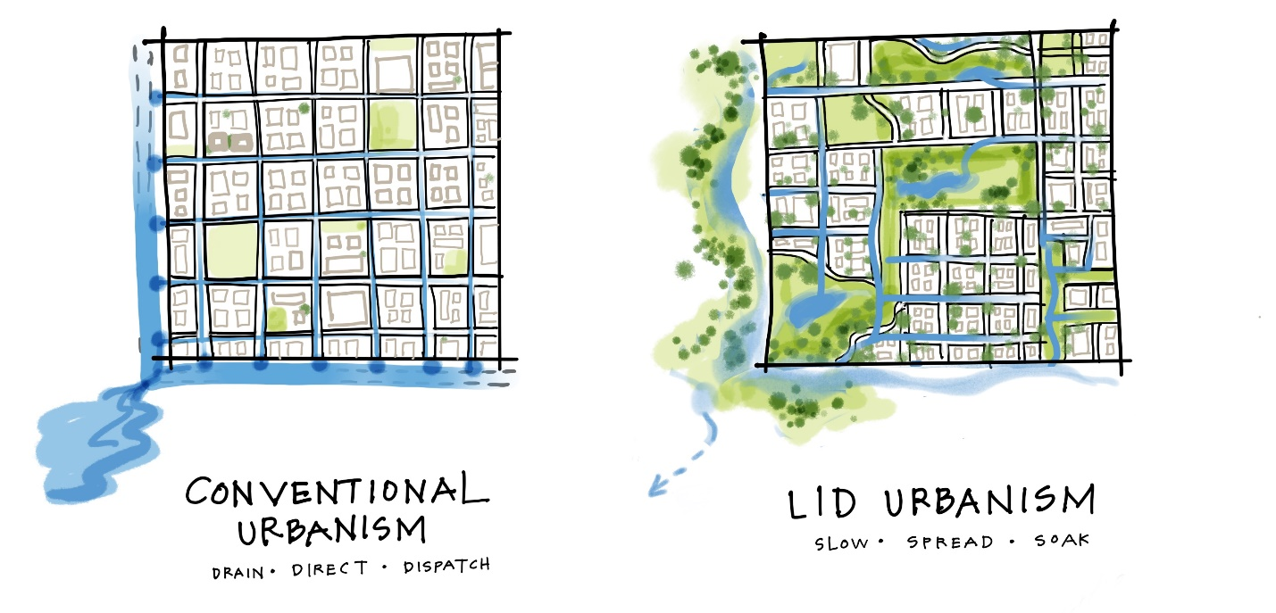
As required by Provisions C.3.a. through C.3.i. in the MRP, these “Low Impact Development” practices are currently implemented on land development projects in the City of Vallejo. Specific methods and design criteria are spelled out in the City’s Stormwater C.3 Guidance.
This Plan details how similar methods will be incorporated to retrofit existing storm drainage infrastructure using green stormwater infrastructure facilities constructed on public and private parcels and within the public right-of-way, with a particular focus on retrofit and redevelopment project opportunities.

City of Vallejo Description and Background

Vallejo Planning Context

Municipal geography
The City of Vallejo is located in the northern San Francisco Bay Area between San Pablo Bay and the Carquinez Strait. The city is surrounded by waterways, wetlands, rolling hills, and open space areas. Vallejo served as the California state capital in the state’s infancy, before the state seat was permanently established in Sacramento. Additionally, Mare Island was the first Naval shipyard on the West Coast. Due to the historic context of the city, Vallejo has many historic buildings. Vallejo is located in an ideal location with links to the surrounding region via road, rail and water. The waterfront area, Mare Island, and downtown are focal points of the community.

Demographics
Vallejo has a population of 118,000 (2016) and is the largest city in Solano County and the tenth largest city in the Bay Area. The population of Vallejo is expected to increase by 5,058 residents between 2010 and 2020. Vallejo is culturally and ethnically diverse with nearly equal portions of the population made up of African American, Asian, Hispanic, and White residents. The median income in Vallejo is $60,767 (2012). The median age is 37.9 (2010).

Economic and Social Trends
Vallejo has a total employment of 31,000 (2016), with primary industries in health care, retail, government, the service industry, the arts and entertainment and recreation. Despite the high number of jobs in Vallejo, the unemployment rate is high (8.1% in 2016) compared to Solano County, the Bay Area, and California as a whole. Prior to closure, the Mare Island Naval base and shipyard was the primary sector of the Vallejo economy, employing 5,800 people in 1993. During World War II, the Mare Island shipyard employed 40,000 people.

Development and Redevelopment Trends
Vallejo is focusing development efforts on enhancing the Downtown area and the conversion of Mare Island to civilian use. Mare Island is a former Naval base and shipyard that closed in 1993. Mare Island is the oldest shipyard and naval facility on the West Coast. The City of Vallejo plans to redevelop Mare Island into a livable workable community within the unique cultural significance of the island.

Commitment and Actions for Sustainability
The City of Vallejo adopted its Climate Action Plan in March 2012. The Climate Action Plan quantifies the city’s greenhouse gas emissions and identifies actions the city may implement to reduce greenhouse gas emissions. The Climate Action Plan identifies Water Reduction Strategies aimed at conserving water consumption and production. This Water Reduction Strategies result in emissions reduction.

Staffing and Scope of Sustainability Programs
The Public Works Department plans to update the Climate Action Plan and sustainability programs. Vallejo staff responsible for the program are the Environmental Services Manager and the Solid Waste and Recycling Coordinator.

Watersheds and Storm Drainage Infrastructure
Subwatersheds within the Solano Permittee jurisdiction are shown in Figure 1-1.
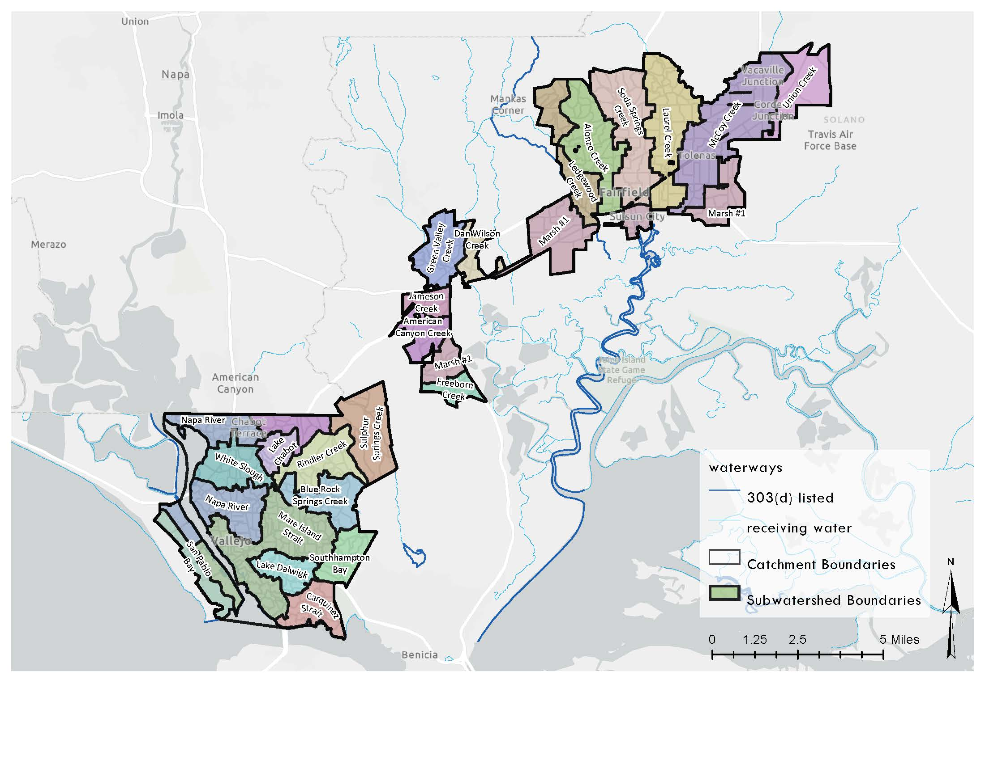
Figure 3-1. Solano Permittee subwatershed boundaries

Major Drainages and Major Drainage Characteristics and Challenges
Main drainages in Vallejo include Austin Creek, draining into White Slough, Blue Rock Springs Creek and Rindler Creeks, both draining to Lake Chabot, and Lake Dalwigk, which collects urban stormwater in South Vallejo.

Storm Sewer System
The storm sewer system in Vallejo is managed by Vallejo Flood and Wastewater District (VFWD), formerly the Vallejo Sanitation and Flood Control District. Stormwater infrastructure includes a storm drain network, detention basins and lakes, and pump stations.

Flood Zones
According to the Department of Water Resources Best Available Maps, flood zones in Vallejo lie primarily around the main drainage channels and basins. This includes areas surrounding White Slough, Lake Chabot and Lake Dalwigk.

Flood Control Facilities
Beginning in 2005, the Army Corps of Engineers designed a project to increase the flood protection capacity of White Slough and Austin Creek. The Army Corps was able to widen a culvert under Highway 37 and install tide gates before federal project funding was withdrawn in 2013.
The Vallejo Wastewater and Flood District constructed Lake Dalwigk and the Lemon Street canal in South Vallejo as a measure to provide 100-year recurrence interval flood protection for the neighboring community. Stormwater collected by Lake Dalwigk is pumped to the Mare Island Strait.

Recent and Planned Drainage Improvements
In 2014-15, the VFWD, the City of Vallejo, and the Fairfield-Suisun Urban Runoff Management Program collaborated on two stormwater pilot projects in Vallejo. The projects were funded through the Clean Watersheds for a Clean Bay Project by a US EPA grant. The projects focused on controlling PCBs and mercury in stormwater runoff from urban areas. Both projects, constructed in 2015, were sited near old industrial urban areas in Vallejo. The projects consisted of the installation of two storm filters downstream of a PG&E substation and a vegetated swale downstream of a railroad corridor. These projects were meant to pilot the cost, design, permitting, and logistical efforts involved in retrofitting stormwater infrastructure.
In addition to these retrofits, the VFWD plans to increase the size of culvert crossings over the next 10 years.

Funding for Maintenance and for Capital Improvements
In their Final Budget for 2018-2019, the VFWD proposed spending over 3 million dollars on stormwater capital projects. Solano County Water Agency administers an ongoing Flood Control Small Grant Program for small projects such as creek vegetation and debris removal, water and sediment retention, and erosion control projects.

Green Stormwater Infrastructure Targets
Provisions C.11 and C.12 in the MRP require Solano County Permittees (City of Vallejo, City of Fairfield and City of Suisun City) to reduce estimated PCBs loading by 8 grams/year and estimated mercury loading by 2 grams/year using green stormwater infrastructure by June 30, 2020. Regionally, Permittees must also project the load reductions achieved via green stormwater infrastructure by 2020, 2030, and 2040, showing that collectively, reductions will amount to 3 kg/year PCBs and 10 kg/year mercury by 2040. Of these regional 2040 reduction targets, the Solano Permittees are responsible for reductions of approximately 110 grams/year PCBs and 47 grams/year mercury.
The Bay Area RAA Guidance identifies three categories of green stormwater infrastructure load reductions:
• Load reductions due to land use changes associated with redevelopment (for example, the conversion of old industrial lands to new residential, recreational (baseball and soccer fields are not uncommon) or commercial areas).
• Load reductions attributable to the implementation of Low Impact Development (LID) features and LID treatment controls, and non-LID treatment controls, on land development projects as required by Provision C.3 in the MRP and its predecessor permits.
• Load reductions attributable to the retrofit of existing streets and developed sites with LID features and treatment controls, and non-LID treatment controls.
This planning process developed and assessed projections for the square footage of impervious surface to be treated with green stormwater infrastructure from future redevelopment or new development within the City of Vallejo’s jurisdiction by 2020, 2030, and 2040 (summarized in Section 4.1). It also incorporates targets for the square footage of impervious surface to be retrofitted and treated with green stormwater infrastructure through potential public and private projects within the City of Vallejo’s jurisdiction by 2020, 2030, and 2040 (summarized in Section 4.2). These targets are associated with the pollutant load reduction estimates in Section 4.3.

Redevelopment and Land Use Conversion
Provision C.3.j.i.(2)(c)
To forecast future development and redevelopment, the City of Vallejo used known information about planned projects and the outputs of UrbanSim. Land use changes were identified from City general plans, specific redevelopment area planning documents, examination of current and historical aerial imagery, and interpreted outputs from the UrbanSim urban planning model. With the exception of the UrbanSim outputs, land use change data were not available in GIS formats and were to be translated from PDF documents and manually digitized in GIS.
UrbanSim is a model developed by the Urban Analytics Lab at the University of California under contract to the Bay Area Metropolitan Transportation Commission (MTC). UrbanSim was developed to support the need for analyzing the potential effects of land use policies and infrastructure investments on the development and character of cities and regions. The Bay Area’s application of UrbanSim was developed specifically to support the development of Plan Bay Area, the Bay Area’s Sustainable Communities planning effort.
MTC forecasts growth in households and jobs and uses the UrbanSim model to identify development and redevelopment sites to satisfy future demand. Model inputs include parcel-specific zoning and real estate data; model outputs show increases in households or jobs attributable to specific parcels. The methods and results of the Bay Area UrbanSim model have been approved by both MTC and Association of Bay Area Governments (ABAG) Committees for use in transportation projections and the regional Plan Bay Area development process.
The Solano Permittees used outputs from the Bay Area UrbanSim model to map parcels predicted to undergo development or redevelopment in each of the three Cities at each time increment specified in the MRP (2020, 2030, and 2040). The resulting maps were reviewed by local staff for consistency with the City of Vallejo’s local knowledge and local planning and economic development initiatives. The general workflow to extract new development and redevelopment parcels mirrored that employed by the Contra Costa County Clean Water Program RAA analysis:
- Intersect the parcel dataset with Solano County MS4 areas
- Export UrbanSim model runs for the years 2010 through 2040 that includes fields that quantify total job spaces, total residential units, and year built.
- Use an if-then statement to flag parcel differences for these metrics between 2010 and 2040 and query the year built output to determine which parcels are estimated to change during each scenario timeframe (2010-2020, 2020-2030, 2030-2040)

It is assumed that new development and redevelopment of multifamily residential and commercial/industrial parcels will incorporate green stormwater infrastructure in accordance with MRP Provisions C.3.b., C.3.c., and C.3.d. Because of high land values, it is expected that more than 50% of existing impervious area in developed parcels will be replaced if a parcel is redeveloped, subjecting the parcel to Provision C.3 requirements (that is, will be retrofit with Green Stormwater Infrastructure), consistent with the “50% rule” requirements of MRP Provision C.3.b.
Existing impervious surface for each affected parcel was estimated using the 2011 National Land Cover Database. Estimates were spot-checked and revised based on local knowledge and available satellite imagery.
Figure 4-1 depicts the locations for future land use conversions in 2020, 2030, and 2040 for City of Vallejo. Based on these assumptions and the revised maps, the amounts of existing impervious surface forecast to be retrofit with green stormwater infrastructure via redevelopment and new development projects are as shown in Table 4-1.
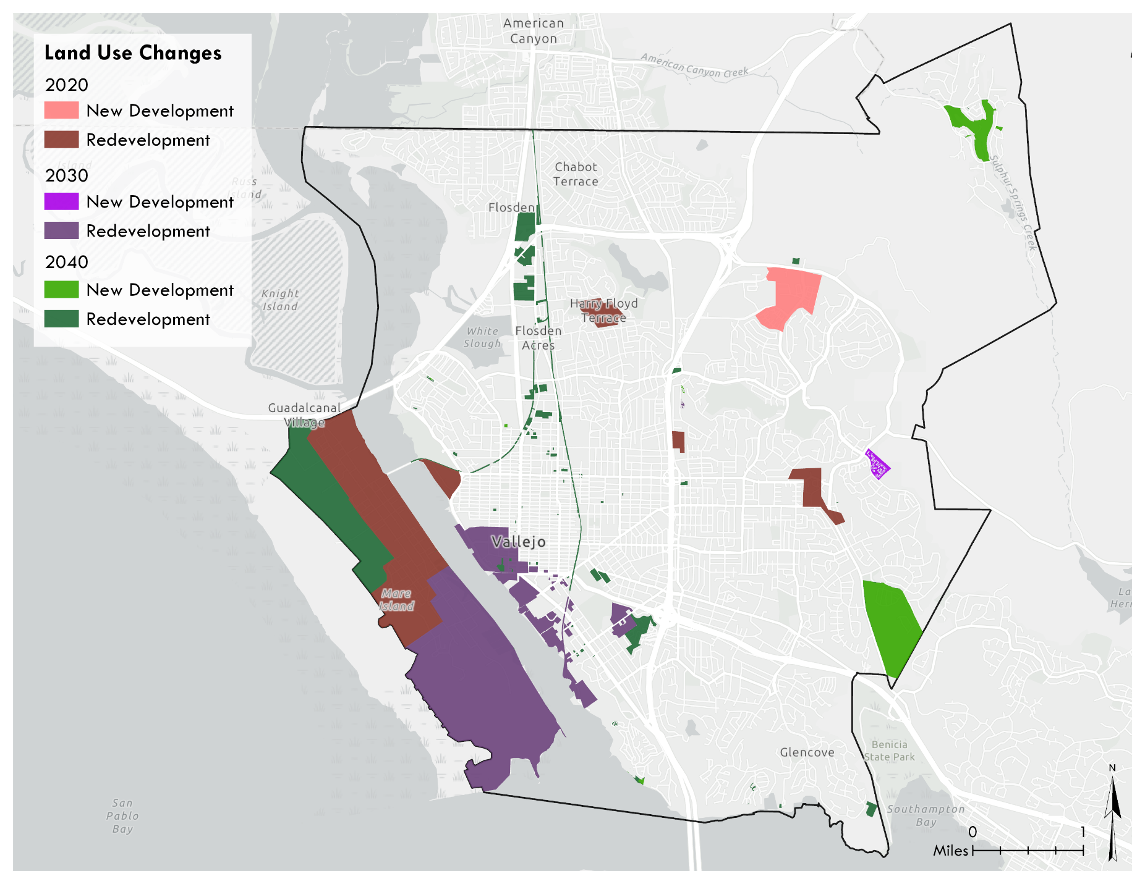
Figure 4-1. Predicted Redevelopment and Land Use Conversion in Vallejo

Table 4-1. Impervious area treated forecasts for GSI on parcels planned for New Development or Redevelopment
NOTE: Acreages are incremental, not cumulative

Specific Green Stormwater Infrastructure Projects
Provision C.3.j.i.(2)(c)
Impervious surfaces that have been or will be retrofit via specific green stormwater infrastructure projects are classified into three project types:
Parcel LID – A combination of structural and non-structural controls that result in runoff and pollutant load reductions. Examples include routing of water to pervious areas on site, downspout disconnection, and/or rainwater harvesting. Specific BMP locations and sizing are not identified.
Decentralized BMPs (dBMP) - Decentralized BMPs drain small areas and infiltrate runoff or attenuate pollutants near their source. Examples are bioretention, infiltration features, or permeable pavement.
Centralized BMPs (cBMPs) - Centralized BMPs drain larger areas such as a neighborhood subdivisions or an entire urban catchment. They route stormwater from its source to a structural treatment feature. Examples are dry basins, infiltration basins, wet basins, or treatment vaults.
Figure 4-2 identifies the locations of existing green stormwater infrastructure projects and those proposed for 2020, 2030, and 2040. The associated estimate of impervious area treated for each green stormwater infrastructure project type is summarized in Table 4-2.
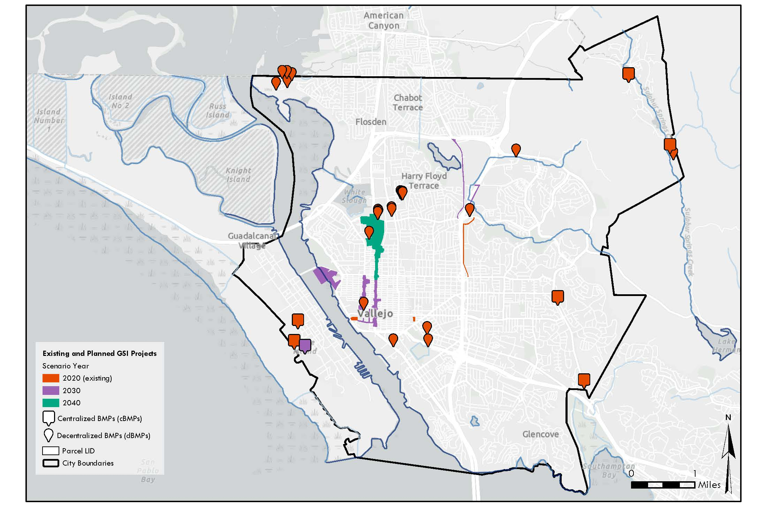
Figure 4-2. Existing green stormwater infrastructure projects and green stormwater infrastructure projects proposed for 2020, 2030, and 20

Table 4-2. Impervious area treated forecasts for specific GSI
NOTE: Acreages are incremental, not cumulative

Projected Load Reductions
As part of the RAA process, the estimates of land use conversion and redevelopment (described in Section 4.1) and the general and specific locations of green stormwater infrastructure projects (summarized in Section 4.2) have been incorporated into a water-quality model to predict mercury and PCB load reductions for 2020, 2030, and 2040.
Details of methods, inputs, and model outputs are included in a separate RAA Modeling Report and draft results are summarized for all the Solano Permittees in Table 4-3 for PCBs and Table 4-4 for Mercury. By 2040, the largest proportional reduction of PCBs and Mercury from green stormwater infrastructure is from land use changes. Conversion from land uses with characteristically high pollutant concentrations to those with much lower concentrations dramatically reduce the PCB and Mercury loading, as depicted in Figure 4-5. While land use conversion driven by redevelopment and new development typically happens at the same time as GSI implementation, and are both included in GSI waste load allocations, they are shown separately in Table 4-3 and Figure 4-5 for clarity on factors driving the reductions.

Table 4-3. Estimated Cumulative PCB Reductions from Green Stormwater Infrastructure

Table 4-4. Estimated Cumulative Mercury Reductions from Green Stormwater Infrastructure

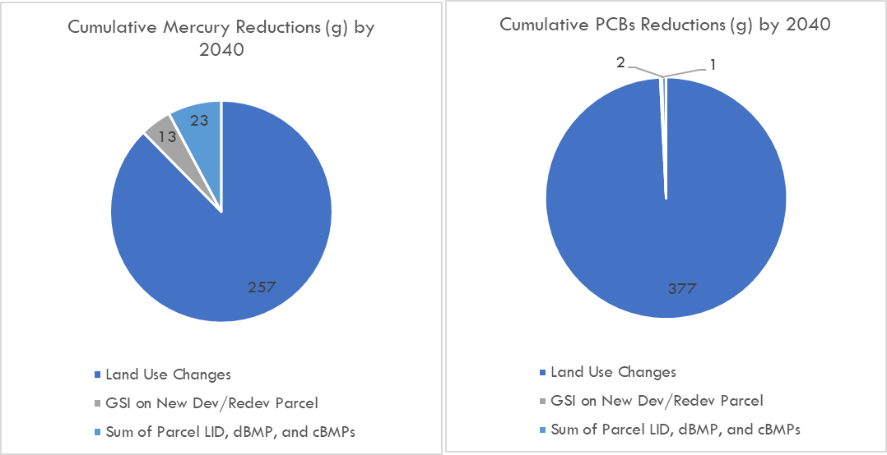
Figure 4-3. Solano Permittees proportional contribution by 2040 of land use changes, New Development/Redevelopment parcels, and combined Parcel LID, dBMPs, and cBMPs to overall reductions from Green Stormwater Infrastructure.
The combined mercury and PCB reductions achieved via the identified and modeled green stormwater infrastructure categories are predicted to meet both the 2020 and 2040 GSI reduction targets. Table 4-5 summarizes the load reductions from green stormwater infrastructure compared to the targets of 8 grams/year PCBs and 2 grams/year mercury by June 30, 2020 and the Solano Permittees 2040 targets of approximately 110 grams/year PCBs and 47 grams/year mercury. The reason that the estimated load reductions exceed targets to such a degree is the inclusion of large areas of redevelopment-driven land use change in the GSI reduction calculations, primarily on Mare Island and the Vallejo Waterfront (see Figure 4-2).

Table 4-5. Predicted compliance with 2020 and 2040 PCB and Mercury pollutant load reduction targets for Green Stormwater Infrastructure.

Project Identification, Prioritization, and Mapping
Provision C.3.j.i.(2)
As described in Section 4.3, the combined existing and proposed GSI projects within the Solano Permittees’ jurisdiction are predicted to fully achieve the PCB and Mercury GSI reduction targets. This section describes the process the Permittees can use to identify and prioritize GSI opportunities considering factors such as project feasibility and environmental benefits.

Tool for Project Identification and Prioritization
A GIS based Desktop Evaluation identified priority parcels and roadways for site assessment and evaluation of potential green stormwater infrastructure opportunities. Prioritization factors incorporated into the evaluation included land use (specific to high probability for PCB and mercury loading), soil, slope, future development or redevelopment plans, parcel size and/or land ownership. The proximity to existing storm drain infrastructure is another important consideration because it indicates a projects’ feasibility to connect overflow or underdrains from a GSI feature to the existing storm drain. The cost and complication of a GSI project increases the further away a parcel or roadway is from existing storm drain infrastructure.
Points were assigned to each of the selected factors and a single parcel and roadway based prioritization shapefile created based on a union of the overlapping factors. The total points were tallied to indicate a relatively high, medium, or low opportunity for GSI implementation.
The spatial prioritization analysis provides a way to combine implementation feasibility, benefit magnitude, and other logistical factors. A geodatabase was constructed to house all of the GIS data and an automated spreadsheet was created for easy adjustments of metrics and weightings. Outputs from the spatial prioritization analysis serves two purposes: 1) provide some practical and immediately actionable alternatives for GSI implementation and 2) identification of additional means to meet GSI and WLA reduction target requirements. Figure 5-1 identifies the areas in darkest green with the highest potential for PCB and Mercury reduction using green stormwater infrastructure.
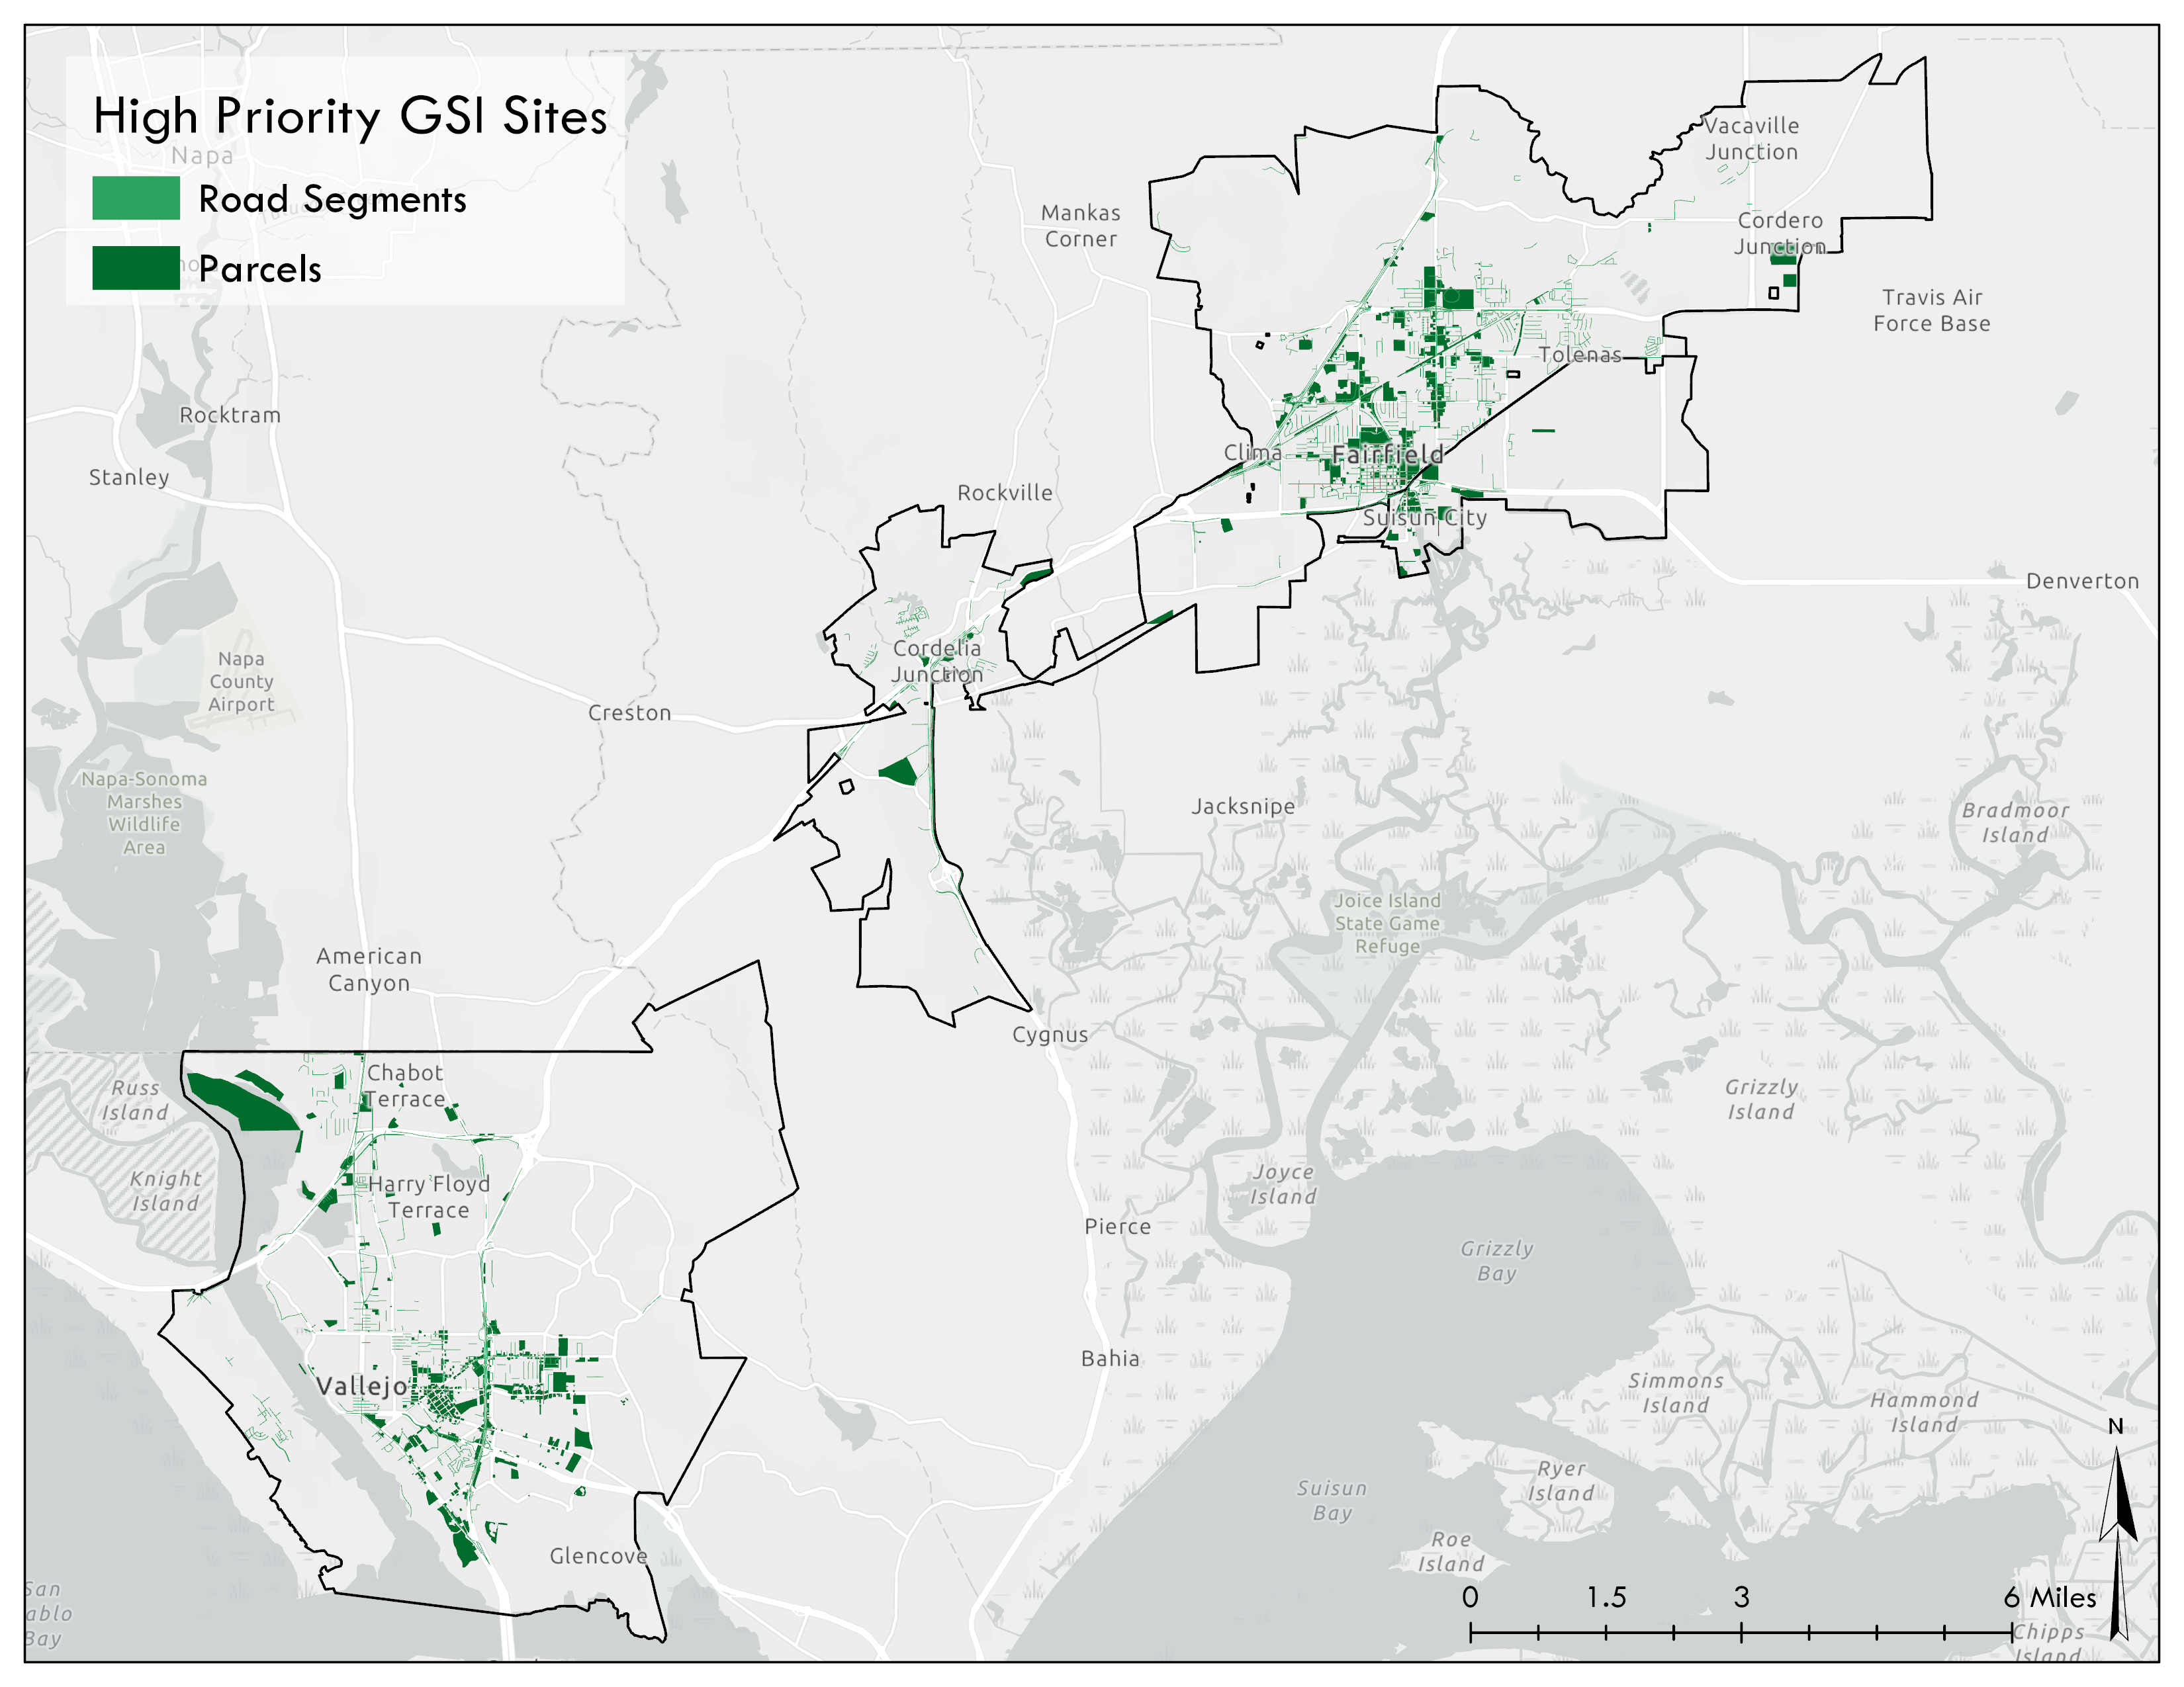
Figure 5-1. High priority parcels and road segments for GSI redevelopment
Green parcels and road segments indicate areas in the top 20% of the priority scores. Most of the parcels or road segments identified in Figure 5-1 are either Old Industrial, Old Transportation or Old Commercial land uses, which corresponds with the highest PCB concentration land uses. These green areas indicate the greatest potential for additional GSI implementation to achieve additional pollutant load reductions.
Given that current GSI reductions exceed the GSI reduction requirements, Solano Permittees may also consider identifying synergistic opportunities within areas that have already been slated for redevelopment in the near future.
Selected opportunity sites identified through this Desktop Evaluation will be followed by a field-based site feasibility assessment by GSI design staff to inform siting and conceptual level designs. For example, limits of sea level rise inundation along with potential conflicts with existing utilities will be considered when identifying, evaluating, and prioritizing sites for potential application of green stormwater infrastructure.

Tool for Project Ranking and Prioritization
In addition to the spatial prioritization tool for project identification, a Project Multi-Benefits Assessment is another tool the Permitees can use to compare and rank individual projects based on their relative benefits. For example, each project will be compared based on its benefit to water supply, flood reduction, water quality, the environment, and the community. Each of these criteria can be weighted based on system understanding along with input from stakeholders. The final ranked projects will be integrated into other planning documents such as Storm Drain Master Plans, the Capital Improvement Project planning process, Complete Streets and other transportation planning processes.
Table 5-2 lists example project multi-benefits, metrics to evaluate each benefit, and criteria weights. Each multi-benefit has a possible score of 10 points which are weighted based on stakeholder input, referred to as the criteria weight.

Table 5-1. Example multi-benefits and metrics to prioritize individual stormwater projects relative to each other using a Project Multi-Benefits Assessment.
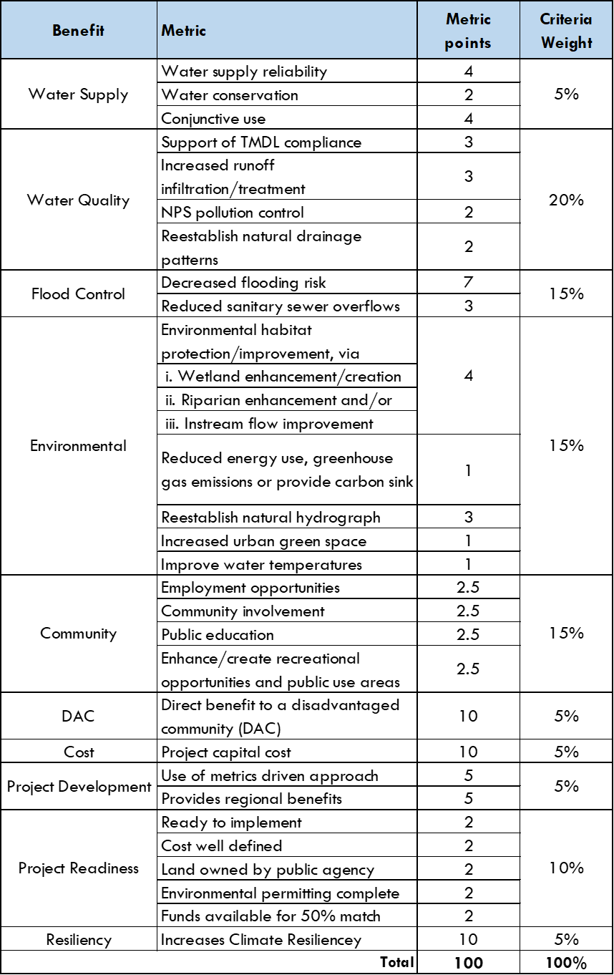

Early Implementation Projects
Provision C.3.j.i.(2)(j)
Existing and early implementation projects include both private development projects regulated under Provision C.3 of the MRP and several City of Vallejo projects where GSI has either been implemented or scheduled for construction in the near term.

Review of Capital Improvement Projects
MRP Provision C.3.j.ii. requires that the City of Vallejo prepare and maintain a list of public and private green stormwater infrastructure projects planned for implementation during the 2015- 2020 permit term, and public projects that have potential for green stormwater infrastructure measures. The City of Vallejo submitted an initial list with the FY 15-16 Annual Report to the RWQCB and updated the list in the FY 16-17 and FY 17-18 Annual Reports.
The creation and maintenance of this list is supported by guidance developed by BASMAA: “Guidance for Identifying Green Infrastructure Potential in Municipal Capital Improvement Projects” (May 6, 2016). The BASMAA Guidance is attached to this document as Appendix A.

Workplan for Completion
Public and private priority projects with green stormwater infrastructure potential identified for future implementation in 2020, 2030, and 2040 are listed in Table 6-1, along with their pollutant removal potential, status, and planning level capital and maintenance costs. Table 6-2 summarizes the planning level project information used to inform the estimates in Table 6-1.

Table 6-1. Public and private projects with green stormwater infrastructure potential identified for future implementation in 2020, 2030, and 2040, along with their pollutant removal potential, status, and planning level capital and maintenance costs. For future scenarios, estimated PCB and mercury reductions are after land use changes have already been applied in the model, so that these reductions only reflect a small portion of the total redevelopment reductions.

Table 6-2. Planning level project information used to inform cost estimation.

Project construction costs were estimated using the EPA National Stormwater Calculator. The calculator utilizes cost curve regression equations developed for green stormwater infrastructure projects types including, impervious area disconnection, rainwater harvesting, rain gardens, green roofs, street planters, infiltration basins, and permeable pavements. Project costs vary depending upon project type, complexity (simple, typical, and complex) and drainage area for the project. The cost curves are useful because they simplify the complexities of cost estimation into easily interpreted curves based on project specific information.
The cost curve complexity depends upon site criteria such as if the project is new development or redevelopment, includes pretreatment, is suitability for GSI implementation, the site topography, and soil type (hydrologic soil group). The output cost from the cost curves is adjusted based on the location of the project.
The following assumptions were applied to all projects for cost estimation purposes:
- Redevelopment project types with poor site suitability;
- The 85th percentile rainfall event was used for design storm sizing (0.67 inches for Vallejo, 0.73 inches for Fairfield, 0.71 inches for Suisun);
- A median climate change scenario;
- cBMP projects were assumed to be infiltration basins and dBMP and parcel projects were assumed to be street planters;
- Design and permitting fees represent 12% of the estimated construction costs;
- Project administration represents City staff effort and represents 16% of the combined design and construction costs; and
- Annual operation and maintenance costs are based on 1% of the combined design and construction costs.

Tracking and Mapping Public and Private Projects Over Time
Provision C.3.j.iv.

Tools and Process
As the Solano Permittees proceed to implement GSI control measures, projects will be tracked in a manner that allows ongoing assessment of stormwater mitigation multi-benefits and spatially explicit quantification of runoff and pollutant load reductions.
Ongoing project effectiveness and BMP maintenance tracking will be accomplished with a stormwater infrastructure geodatabase and the regional watershed spreadsheet model, similar to the tools implemented in the 2NFORM Platform currently used by Solano Permittees. The project tracking system will include field data capture via datasheets or mobile apps, inspection protocols for decentralized and centralized structural BMPs, and a protocol to field verify non-structural BMPs. Overall effectiveness tracking for projects will be based on the estimates of cumulative annual runoff and pollutant load reductions calculated for implemented projects and comparison with the target GSI load reduction targets.

GIS Tracking tool
GSI implementation data will be stored in a geodatabase linked to hydrographic data that describe the urban drainage system that includes urban catchment delineations, stormwater infrastructure, catchment outfalls, and connectivity to receiving waters. This will facilitate quantification of stormwater pollutant load reduction that may require a routing component and/or integration with source controls for tracking progress towards pollutant waste load allocations. The geodatabase will also include data layers required for estimating runoff and pollutant loading to BMPs, such as impervious surface coverage, rainfall, soil types, land use, and slope. GSI project implementation data will include a hierarchy of implementation types that includes non-structural parcel LID, decentralized BMPs, and centralized BMPs. When available, individual BMP data will be stored within the geodatabase and linked to both the GSI project level data and the catchment spatial data.

Pollutant load reductions tracking
The primary unit of analysis will be the urban catchments (100 acres) that have already been delineated for each of the Solano permittees. Reductions will be sequenced to avoid double counting within each catchment, with reductions occurring first on parcels and road segments and next at any regional treatment facility within the same drainage. The outputs will allow mapping of the spatial patterns of reductions annually and summing of PCB and Mercury reductions for each MS4. Reductions will be calculated according to individual BMP specifications, C3 BMP runoff capacity requirements, pollutant removal efficiency of different BMP types, and estimated loading to each BMP based on their drainage areas. Calculations will be carried out within a GIS or using spreadsheets that maintain linkage to a desktop GIS via association of individual BMPs to GSI projects, parcels, and catchments. This data structure has already been created as part of this GSI Workplan will continue to evolve according to Solano Permittee tracking and reporting needs.
For each annual reporting cycle, subsequent reductions will carry over into the next year, provided that BMPs are continuing to function to an adequate performance level which will be verified with regular field inspections. The same calculation methods will be used each year other than when new information becomes available. For example, catchment drainages may need to be updated, or a new BMP type may be implemented that was not previously used. Over time, additional redevelopment and GSI implementation will add to the estimated PCB and Mercury reductions.
Tracking GSI Projects and BMP performance status will become more complex as GSI implementation grows and a tighter coupling between the reductions calculations and the GIS may be necessary to avoid errors and create an efficient reporting workflow. In addition to fulfilling reporting requirements, spatially based load reduction tracking will provide information to help prioritize future GSI projects as loading patterns change and new implementation opportunities and priorities emerge.

Design Guidelines and Specifications
The MRP requires that the GSI Plan include general design and construction guidelines, standard specifications and details (or references to those documents) for incorporating GSI components into projects within the City. These guidelines and specifications should address the different street and project types within the City, as defined by its land use and transportation characteristics, and allow projects to provide a range of functions and benefits, such as stormwater management, bicycle and pedestrian mobility and safety, public green space, and urban forestry.
The Solano Permittees have developed a Green Stormwater Infrastructure Design Guidebook (Design Guidebook) to reflect the best local and national GSI planning and design practices. The Design Guidebook also reflects the unique challenges and specific needs for constructing GSI within the cities of Fairfield, Suisun City, and Vallejo. The Design Guidebook is a tool for identifying and incorporating green stormwater infrastructure into the built environment, including into existing and proposed streets, parking lots, and landscape areas. The four primary chapters are organized to identify these green stormwater infrastructure integration opportunities.
Chapter 2. Green Stormwater Infrastructure Types. This chapter defines a common and consistent terminology for use throughout the Solano Permittees’ GSI planning initiatives.
Chapter 3. Streetscape and Project Design Guidelines for Green Stormwater Infrastructure Projects. This chapter illustrates types of GSI opportunities in the Permittees’ jurisdictions, specifically in right-of-ways, parking lots, and public spaces; provides GSI landscape design criteria; and identifies considerations for GSI maintenance and post-construction performance.
Chapter 4. Green Stormwater Infrastructure Standard Specification and Design Details. Provides a suite of GSI details and specifications for integration into Permittee standards.
Chapter 5. Green Stormwater Infrastructure Sizing Requirements. Explains GSI sizing requirements; Regulated Projects should consult and comply with each Cities’ separate C3 Guidance documents.

Guidelines for Streetscape and Project Design
Provision C.3.j.i.(2)(e)

Description of Guidelines
Design guidelines are sets of recommendations towards good practice in design. They are intended to provide clear instructions to designers and developers on how to adopt specific principles, such as intuitiveness, learnability, efficiency, and consistency. Design guidelines convey general policies and best practices in the design of stormwater features in new and retrofit environments. They do not dictate solutions and instead, they define a range of appropriate responses to a variety of specific design issues.
Design Guidelines support the development of a common understanding of GSI design principles and standards. Maintaining a high quality of stormwater infrastructure ensures that the community not only meet its important regulatory requirements but also directs investments in ensuring aesthetic standards and helps to achieve the community’s goals on a wide range of issues. Therefore, these guidelines and the associated design review process through which they are administered promotes the functionality and performance for stormwater as well as the contribution of the project to larger community goals. Recognizing this, the Solano Permittees have established GSI design guidelines.
The goal of the Design Guidebook is to be a Green Stormwater Infrastructure design, planning, and implementation tool that will support the Permittees to achieve water quality targets linked to other community priorities to realize multiple benefits and efficiently invest public dollars. Though implementation is often driven by regulations, GSI planning and design is best when linked to other community priorities to realize multiple benefits and efficiently invest public dollars. For example, green stormwater infrastructure can be integrated into right-of-way improvements to promote active transportation or Complete Street approaches as illustrated in Chapter 3 of the Design Guidebook, included in Appendix B.

Specifications and Typical Design Details
Provision C.3.j.i.(2)(f)

Description of Specifications and Typical Design Details
Linking GSI implementation with other community priorities creates an opportunity to cost effectively balance GSI construction and operation and maintenance costs. One means to achieve this balance is GSI integration into the Permittee’s standard practices, starting with the design details and specifications included in Chapter 4 of the Design Guidebook, included in Appendix B. Every capital project, every street improvement, every private development is an opportunity to integrate GSI into planned investments and capitalize on GSI’s multiple benefits.
The green stormwater infrastructure details and specifications have been selected to support integration of GSI into standard practices, for example in street design, municipal capital projects, and to support private development review. Implementation of a GSI strategy will require cross departmental coordination with planning, operations and maintenance. These details and specifications can support the design and construction of GSI practices in the Permittee jurisdictions.
The typical details and specifications were developed to be revised and customized as needed for each individual project by design professionals. They show typical configurations, rather than a required City standard configuration. This distinction is deliberate. We recognize that to create functional, contextual, and aesthetic green infrastructure projects, design professionals must use their professional judgment and creative thinking to be responsive to each site-specific condition.
AutoCAD drawings of these typical details are provided so that design professionals can modify the plan, sections, call-outs, and/or construction notes to address the projects site-specific conditions. To allow for site-specific design adjustments the typical details are developed as “not for construction” drawings. The typical details are formatted, organized, and developed with the necessary informational tools to guide the design professional through the proper selection, layout, and design of GSI.

Sizing Requirements
Provision C.3.j.i.(2)(g)

Description of “single approach” to GSI sizing prepared through BASMAA
Where possible, GSI measures should be designed to meet the same sizing requirements as Regulated Projects. However, if a GSI measure cannot be designed to meet this design standard due to constraints in the public right-of-way or other factors, the measure can still reduce runoff, improve water quality and achieve other multi-benefits (e.g., traffic calming, pedestrian safety, etc.). For these situations, the Design Guidebook in Appendix C describes regional guidance for sizing in Chapter 5.
Regulated Projects must comply with each Cities’ separate C3 Guidance for specific LID and GSI requirements, and private developers are encouraged to use the Design Guidebook as a resource.

Funding Options
The MRP requires that the City develop a funding strategy for the implementation of the GSI Plan. Permittees should develop both local strategies, as an individual municipal agency, and collaborate with the other Solano Permittees to develop regional funding strategies that require the coordination of multiple agencies and permittees similar to that described in the “Roadmap of Funding Solutions for Sustainable Streets” developed by the Bay Area Stormwater Management Agencies Association for Urban Greening Bay Area Initiative. This section first outlines the regional and then local efforts identified by the Solano Permittees the City’s respective actions and anticipated timelines.
The Solano Permittees reviewed the funding strategies outlined by the San Mateo County Green Infrastructure Funding Nexus Evaluation and selected strategies that best reflect the respective capacity, opportunities and unique conditions in their communities. They have identified efforts already under way and then created timelines that work best for their local contexts. Section 9.1 describes the Permittees’ regional and then local funding strategies. Appendix C includes a summary table outlining all the funding options evaluated by the Permittees.

Funding Strategies Developed Regionally
Provision C.3.j.i.(2); TRT Item 15C
The Regional Roundtable on Sustainable Streets convened meetings with local, regional, state, and federal agencies, private sector and non-profit partners in 2017 to identify solutions for obstacles to funding projects that include both GSI and transportation improvements. The final report of the Roundtable process is the Roadmap of Funding Solutions for Sustainable Streets (Roadmap, BASMAA 2018), which identified specific actions to improve the capacity – both statewide and in the San Francisco Bay Area -- to fund Sustainable Street projects that support compliance with regional permit requirements to reduce pollutant loading to San Francisco Bay, while also helping to achieve the region’s greenhouse gas reduction targets.
The Roadmap presents the results of the evaluation of grant and loan monies that may be used to fund projects that include both GSI and transportation improvements. The results of this evaluation are presented in two tables, which are described below and reproduced in Table 9-1:
- Table B-1, Transportation Funding Sources that May Potentially Fund Sustainable Streets, identifies nine transportation grants, and provides an evaluation of the conditions under which green stormwater infrastructure is eligible for funding.
- Table B-2, Resource-Based Grant and Loan Programs that May Potentially Fund Sustainable Streets, identifies nine resource-based grant and loan programs and provides an evaluation of the conditions under which transportation is eligible for funding.
These tables will be consulted as part of developing a funding plan for prioritized projects as they are advanced in the City’s capital improvements program.
Table 9-1. Grant and loan monies that may be used to fund projects that include both GSI and transportation improvements
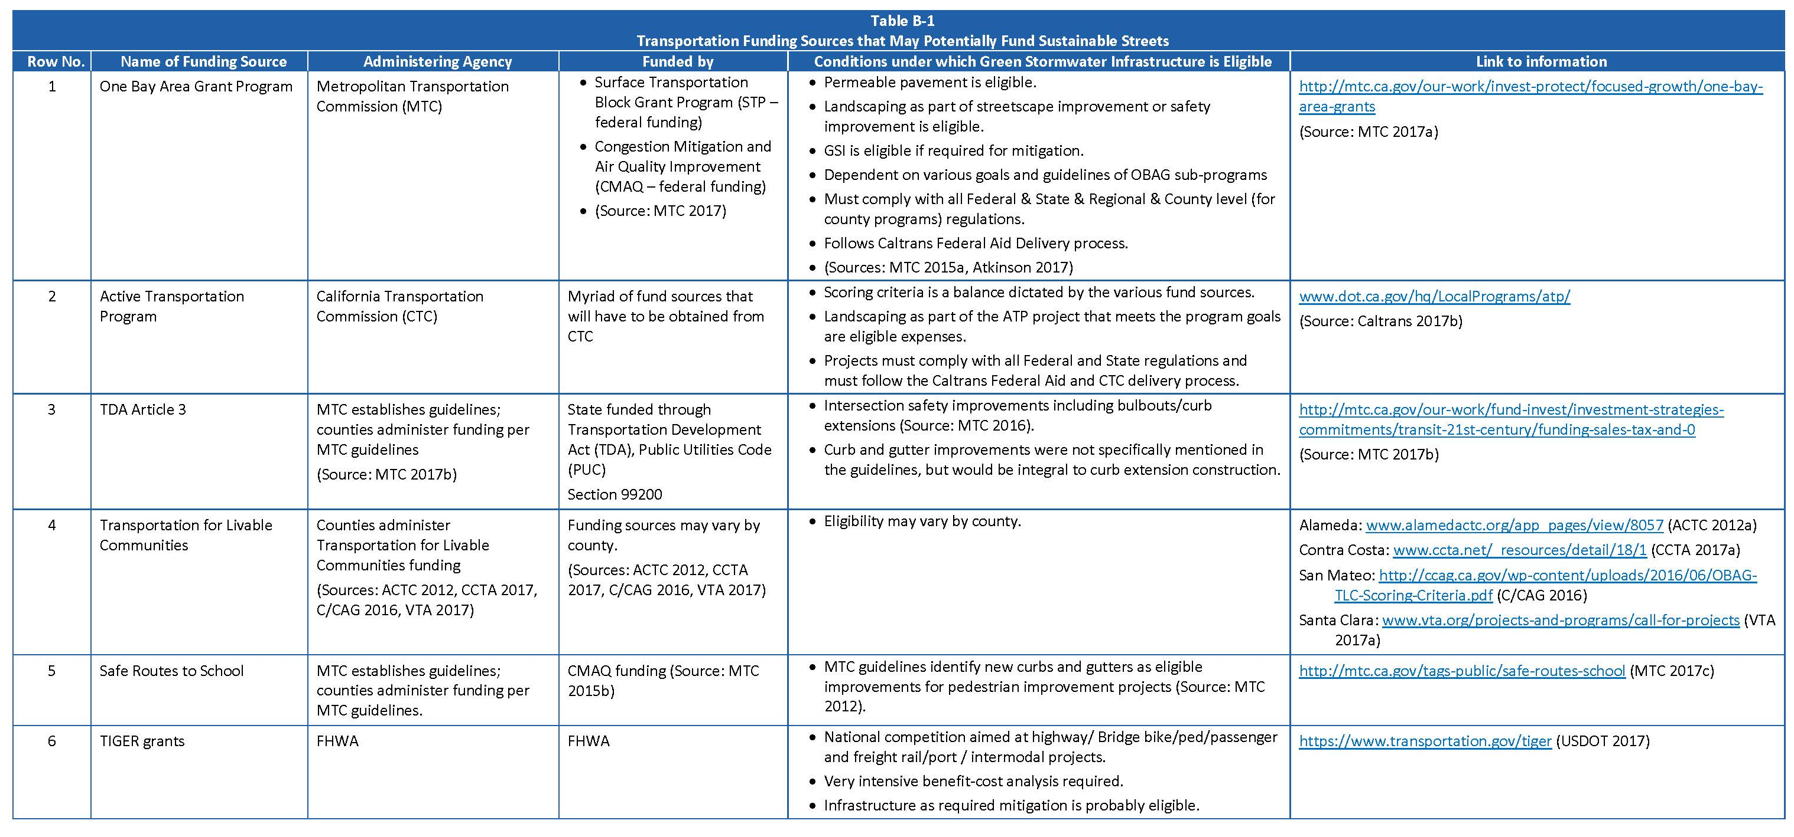

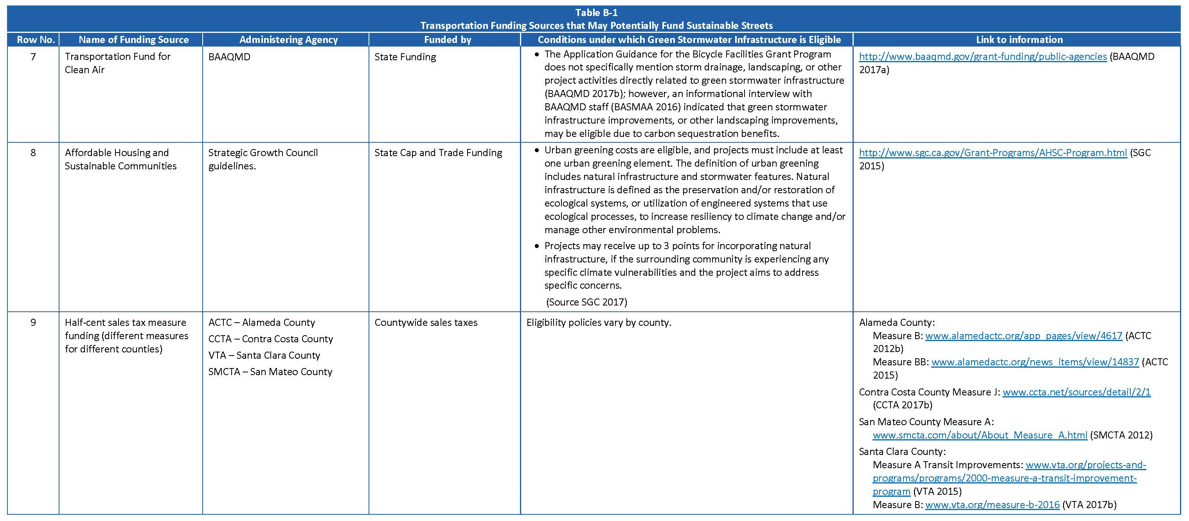

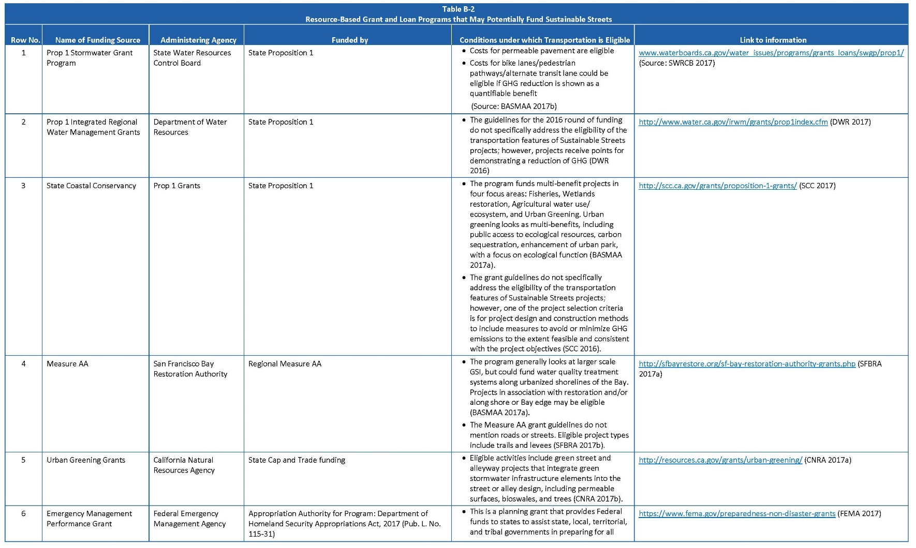

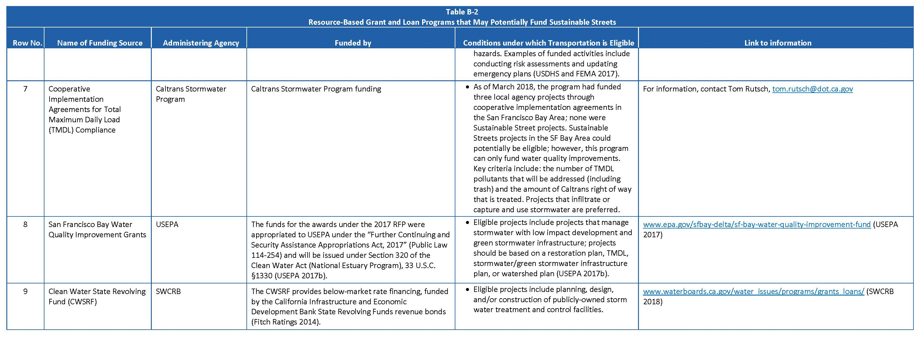

Local Funding Strategies
Provision C.3.j.i.(2)(k)
The Solano Permittees considered both locally balloted and non-balloted funding options for implementing their prioritized GSI projects. The Cities prioritized the potential opportunities according to a feasibility criterion given the level of effort required as well as the strategy’s perceived impact and risk. These criteria were used to determine whether to include the strategy and create a proposed timeline for development. Each community has varying competing needs and resources within its jurisdiction and the following recommendations reflect those relative political, financial and organizational contexts. Attachment D is a table of the consolidated funding strategies with descriptions of the funding options considered by the permittees, potential uses for the funds, the pros and cons associated with the various funding options, and general comments from the permittees.

Balloted Funding Options
The Permittees reviewed three balloted funding options including Parcel Taxes, Property Related Fees and General Obligation Bonds. Each Permittee assessed that all three would each require a high level of effort to gain community acceptance and would be high risk of not passing and categorized them as a long-term project that would take up to 15 years to implement.

Non-Balloted Funding Options
The Non-Balloted funding options are listed by their recommended timelines below:

Already Implemented/Short Term (up to 5 years)
Grants. All three Permittees will pursue grant opportunities which are considered a low risk and require a relatively low level of effort. For example, City of Vallejo is committing its Environmental Services Manager to seeking grant resources and Suisun City is already in the process of pursuing grants.
Community Facilities Districts (Mello Roos) are already implemented for new development in the City of Vallejo.
Business Improvement District. City of Vallejo has two existing Business Improvement Districts and plans to engage those communities about the advantages of GSI.
Multi-Agency Partnerships. All the Permittees identified Multi-Agency Partnerships as a high priority, low risk and low effort strategy to pursue. City of Vallejo listed as examples their existing partnerships with the City of Benicia, Solano Transportation Authority, Caltrans to implement GSI. The cities of Fairfield and Suisun City, through multiple program efforts, partner with Solano Resource Conservation District to achieve Program compliance for water quality monitoring, and Public Information and Parti cipation. Furthermore, the cities through Program efforts also partner with Solano Irrigation District, Solano County Water Agency, the city of Benicia, the city of Dixon and the city of Vacaville.
Caltrans Mitigation Collaboration. All the Permittees identified collaborating with Caltrans as a high priority, low risk and low effort strategy to help Caltrans achieve TMDL compliance for water quality impacts associated with both local streets and the highway right-of-way.
EPA Financial Capability Assessments. The EPA’s “Financial Capability Assessment Framework for Municipal Clean Water Act Requirements” allows communities that meet financial capability criteria the ability to apply for delayed schedules for compliance with some of their NPDES stormwater permit elements. It is designed to help communities develop a more accurate and complete picture of their ability to pay for Clean Water Act obligations, emphasizing factors beyond the 2% threshold for median income. All the Permittees prioritized conducting an assessment to determine whether they qualify for a delayed compliance schedule.
Realignment of Services. Both City of Vallejo and Suisun City have been realigning services (short term) and City of Vallejo will continue to do this into the medium term as money allows.
Benefits Assessments. City of Vallejo has implemented a Benefits Assessment on all new development.
Transportation Opportunities. All the Permittees will investigate opportunities for collaborative implementation of GSI through their transportation projects.

Medium Term (5-10 years)
Community Facilities Districts (Mello Roos) were considered a medium-term priority for City of Fairfield and Suisun City will consider them for new developments.
Regulatory Fees. All the Permittees commit to investing effort into developing funding from their regulatory fees for services such as plan check and inspection fees related to stormwater and GSI.
Alignment of Services. All three Permittees commit to a realignment of services such as water supply, sewer and refuse collection in the next 5 to 10 years. The Permittees would look for opportunities to reorganize management, staffing, services units and/or budgets from traditional stormwater management services that can be integrated with the more easily funded water, sewer and/or refuse collection or flood control or transportation agencies. Examples include using GSI to promote groundwater recharge, trash capture or rainwater harvesting and reuse.
Business License Fees. City of Fairfield considers the development of a Business License Fees with a direct nexus with stormwater quality as a medium-term goal.
Developer Impact Fees. All three Permittees will invest time to create Developer Impact Fees for GSI charged by municipality in connection with conditions of approval. The funds would offset public costs associated with the development and will require a high level of time to develop and implement.
Benefits Assessments. City of Fairfield and Suisun City are committing to developing these assessments in the next 5-10 years and Suisun City will do this for new developments.
Partnerships and Other Strategies. City of Vallejo is considering a Public Private Partnership with the Mare Island Developers to help build and maintain public infrastructure.
Volunteer Programs. All three Cities consider the development of a volunteer program to steward the GSI projects, conduct habitat stewardship and protection, planting and maintaining landscaped improvements to require a high degree of effort and risk and therefore will take time to develop.

Long Term (10-15 years)
Business Improvement Districts. City of Fairfield and Suisun City both ranked seeking funding for GSI from Business Improvement Districts as a long-term strategy with Suisun City indicating that it would be a low payback strategy as the local Business Improvement District currently relies entirely on City services and would be unlikely to assess themselves to pay for GSI.
Enhanced Infrastructure Financing Districts. This strategy is uniformly seen as requiring a high level of effort and time and a long-term potential for all the Permittees. For example, City of Vallejo noted that implementation and ongoing management would require a great deal of time.
Business License Fees. City of Vallejo and Suisun City will develop Business License Fees related to stormwater as a long-term goal as it is potentially a low payback and has the potential to discourage businesses from moving into the Permittees’ jurisdiction.
Realignment of Services. Suisun City will continue to realign its services into years 10-15.
Loans. While it will require a high level of investment and risks, City of Vallejo commits to pursuing loans into years 10-15.
Alternative Compliance. All the Permittees will work to develop an alternative compliance program for new and off sight redevelopment projects. All the Permittees consider alternative compliance as higher risk with high levels of effort to implement.
Partnerships and Other Strategies. Fairfield and Suisun estimate the development of Public Private Partnership with private entities to help build and maintain public infrastructure will be both high risk and require a high level of effort and therefore a longer-term effort.
In Lieu Fees. In-lieu fees as a source of funding for regional projects would require a high degree of effort with high-risk. City of Vallejo also notes that it would also require a lot of inter departmental collaboration.

Integration with City Plans & Documents
Provision C.3.j.i.(2)(h)
To ensure effective implementation of the GSI Plan, the GSP Plan goals, priorities and strategies should align with the City’s planning documents and policies. The MRP states that the GSI Plan include:
“(h) A summary of the planning documents the Permittee has updated or otherwise modified to appropriately incorporate green infrastructure requirements, such as: General Plans, Specific Plans, Complete Streets Plans, Active Transportation Plans, Storm Drain Master Plans, Pavement Work Plans, Urban Forestry Plans, Flood Control or Flood Management Plans, and other plans that may affect the future alignment, configuration, or design of impervious surfaces, including, but not limited to, streets, alleys, parking lots, sidewalks, plazas, roofs, and drainage infrastructure. Permittees are expected to complete these modifications as a part of completing the Green Infrastructure Plan, and by not later than the end of the permit term.
(i) To the extent not addressed above, a workplan identifying how the Permittee will ensure that green infrastructure and low impact development measures are appropriately included in future plans (e.g., new or amended versions of the kinds of plans listed above).”
This Section describes the various municipal planning documents that were evaluated to determine to what extent they were aligned with the GSI Plan. Overall, no planning documents were identified that prevent the implementation of GSI projects within the City. Moreover, some planning documents already contain language to support the GSI Plan. However, various plans need to be better aligned with the GSI Plan to require the integration of GSI and use of the various tools, specifications and guidelines addressed in this Plan and through subsequent implementation. Examples of language supporting GSI in these documents are provided in Appendix D.

Related Regional and Countywide Plans and Planning Documents
This Plan has been coordinated with the Solano Permittees Reasonable Assurance Analysis (RAA). The RAA for Green Stormwater Infrastructure is being prepared by collectively by the Solano Permittees and is consistent with guidance prepared by the Bay Area Stormwater Management Agencies Association (BASMAA). The RAA for Green Stormwater Infrastructure uses a water quality model coupled with continuous simulation hydrologic output to estimate baseline loadings of pollutants and the reductions that might be achieved through green stormwater infrastructure implementation in 2020, 2030, and 2040 under various scenarios, which include implementation of projects identified in this Plan. Results pertinent to green stormwater infrastructure planning and implementation are discussed in Sections 5 and 6 of this Plan.

Existing City Plans that Support GSI
The City has several planning documents that address different elements related to GSI, including land use, transportation, sustainability, conservation, urban forestry, environmental leadership, infrastructure, and housing. Table 10-1lists the plans that the City has reviewed to determine the extent to which GSI related language, concepts and policies have been or could be incorporated.

Workplan for Future Integration of GSI Language into City Plans
In the future, new plans and updates to existing plans will contain appropriate language to further support the GSI Plan as needed. The plans identified in Table 10-1 will be further amended with GSI language during the update process for each plan, and for some, an interim policy will guide the City’s work until the respective document update. Appendix D describes specific language with GSI references.
If these updates do not occur during the current permit term, an interim policy will be adopted by the City to follow the GSI Plan and related documents created during its implementation. City staff will support the City’s plan development process when revising or updating existing planning documents or when developing new planning documents in order to ensure that GSI requirements and policies are incorporated. Examples of GSI-related language can be found in references such as SCVURPPP’s Model Green Infrastructure Language for Incorporation into Municipal Plans (2016). Finally, the adaptive management process described in Section 13 will help ensure this requirement is met.

Table 10-1. City Plans and Documents and Status of GSI Integration
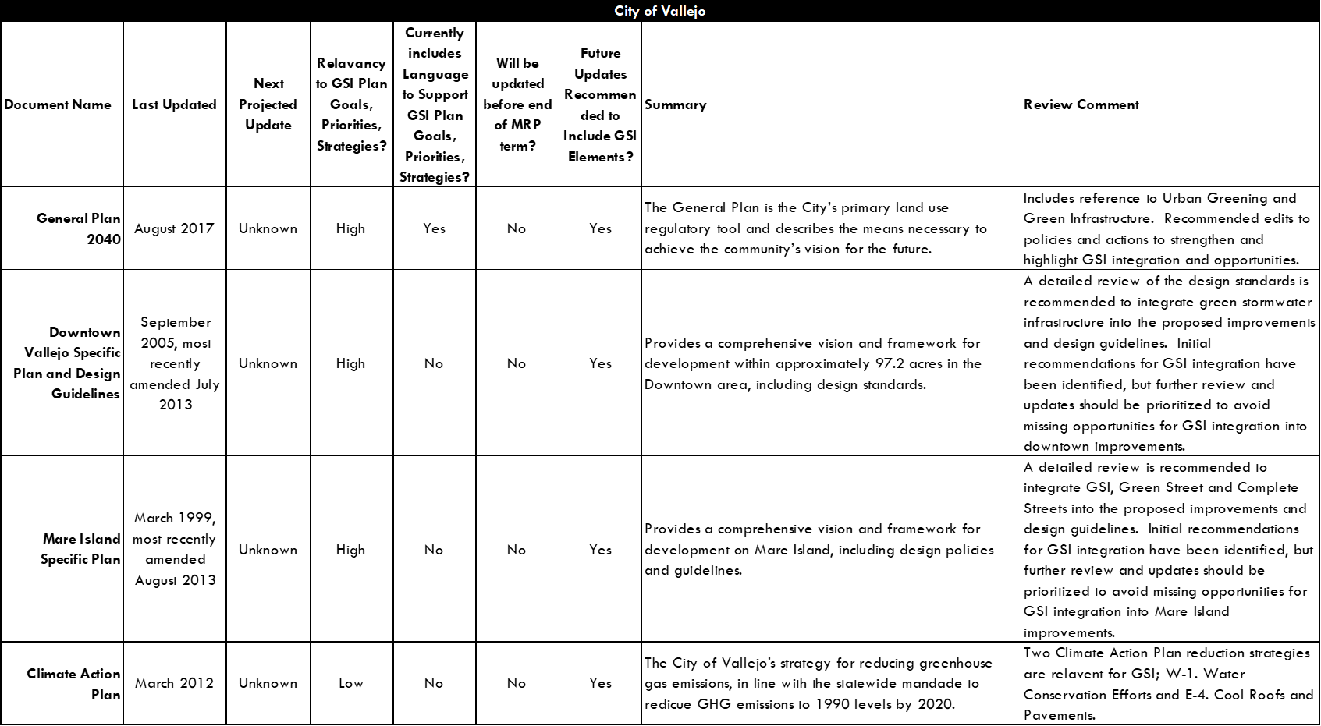

Outreach and Education
Provision C.3.j.i.(4)
The City of Vallejo’s Green Stormwater Infrastructure Plan development process engaged a wide variety of stakeholders, including both government staff and community members who will live, work, and play near future green stormwater infrastructure projects. The City of Vallejo also intends to engage relevant government staff and community members as projects move forward towards design and implementation.

Interdepartmental Meetings and Trainings
To get support and commitment to the GSI Plan and this new approach to urban infrastructure, educating department staff, managers, and elected officials about the purposes and goals of green stormwater infrastructure, the required elements of the GSI Plan, and steps needed to develop and implement the GSI Plan was an important step in the development of the GSI Plan. The City began this process in fiscal year 2015-2016 and to date has completed the following tasks:
- Engineering Services staff attended the a GSI workshop covering GSI design guidelines; implementing GSI projects, the GSI Design Guidebook; and GSI landscape and maintenance considerations.
- In-house training was provided February 4, 2019 to Planning and Engineering Services Department staff on GSI requirements, strategies, and opportunities.
- Interdepartmental meetings with affected department staff and management have been held to discuss GSI requirements and assigned tasks.
- The MRP requirements to analyze proposed capital projects for opportunities to incorporate GSI were discussed with Planning Department staff.

Public Outreach and Education
Public and stakeholder support is also essential for the successful implementation of the GSI Plan and future GSI projects. There were several opportunities for public participation in the development of the GSI Plan, including through a GSI website and public outreach events and presentations.

Updates on the development of the GSI Plan were presented at public outreach events and a City webpage (www.city.org/gsi) was established to provide information to the public and will be periodically updated. The website will also serve as a home for the Final GSI Plan.
For Elected Officials, the Solano Permittees developed a factsheet and a brief presentation for Cities to use in conducting outreach to elected officials on GSI.
The City will continue to conduct education and outreach about GSI as the GSI Plan is implemented.

Policies, Ordinances, and Legal Mechanisms
Provisions C.3.j.i.(3) and C.3.j.i.(5)(c)
The Solano Permittees reviewed numerous policies, programs and business practices that could be implemented to streamline, require, incentivize and integrate the planning and implementation of green stormwater infrastructure. The concepts were gathered through examples from existing programs, examples from the Resilient by Design results and best practices from around the country. The team assessed whether strategies were already underway, discussed the relative levels of effort required, the potential return on investments and perceived risk and resources needed. These criteria were used to determine whether to further evaluate the strategy and how it best fit into the Permittees respective GSI planning timelines. Each Permittee evaluated these strategies against their communities’ current opportunities and constraints and reflect their unique conditions. The short, medium, and long-term strategies are described below in no particular order.

Integrated Planning
Integrated Watershed Planning. The Permittees considered performing integrated watershed planning whereby they would work with the community to create a vision for an integrated watershed plan that considers stormwater, water supply, flood resiliency, climate change adaptation and GSI into parks, schools, streets, water fronts and flood control facilities. By working with the community and stakeholders, the Permittees would increase the likelihood of agency partnerships, shared funding and City family buy in. Vallejo and Suisun City will apply integrated watershed planning over the long-term with Fairfield Considering this a a medium-term strategy, recognizing it requires a high degree of effort. At the time of this writing, the City of Vallejo is onboarding an Environmental Services Manager to engage the public and create a defined vision for their community.
Conduct Integrated and Collaborative Capital Planning. All the Permittees indicated they are implementing GSI in their various capital projects and are amplifying benefits across various land uses (streets, parking lots, schools, parks and other large landowners). They have created an interagency process to conduct collaborative capital planning and are able to harness existing projects and funding streams. For example, Vallejo is planning on continuing this practice with Caltrans, Solano Transportation Authority, and the City of Benicia.

Align Stormwater with Climate Resiliency
The implementation of green stormwater infrastructure, adaptation to sea level rise and planning and design for increased flooding and rain intensity can have multiple areas of overlap for planning, funding and implementation. By conducting integrated planning as described in Section 12.1, the Permittees can best direct funding and investment for both stormwater and flood resiliency and sea level rise to create multi-benefit solutions, reduce risk to vulnerable populations and infrastructure and increase the potential number of funding partners. By participating in the development of shared plans and regional efforts to prepare for climate change, the Bay Area will better compete for state and federal dollars. City of Vallejo considers this a long-term effort that would require increased staff resources and time but will make small changes immediately to move in this direction. Fairfield and Suisun will both will pursue this aligned planning approach within the medium time frame.
Broaden the Definition of GSI. GSI is tool in a suite of solutions called, "nature-based solutions" an umbrella term that includes actions to protect, sustainably manage, and restore natural or modified ecosystems that adaptively provide human well-being and biodiversity benefits. This can include natural sea level rise management using wetlands and living levees, dunes, floodable greenspaces, and natural spaces that allow for the natural hydrological cycles to function. Each Permittee will broaden the definition of GSI in the short term, though it doesn’t directly benefit the goals of the stormwater program.
Integrate GSI with Sea Level Rise Planning. Both City of Vallejo and Suisun City identified addressing sea level rise and exploring the use of managed retreat or the development of natural berms as a longer-term effort requiring a high level of effort. City of Fairfield will explore these options in the medium term.
Integrate GSI into Resiliency Funding. Resiliency projects generate multiple cross sector partners and can attract multiple funding sources, such as transportation and water grants. City of Vallejo plans to pursue resiliency funding with the potential to integrate GSI in the shorter-term, for example through grant writing with their new Environmental Services Manager, while Fairfield and Suisun consider this a medium-term effort.
Link GSI to Flood Resiliency. Local stormwater harvesting and floodable spaces can be developed with GSI planning and could be coupled with the integrated watershed plans mentioned in Section 12.1. Each of the Permittees acknowledge this effort requires a significant amount of time and resources. Vallejo and Suisun will pursue GSI linked flood resilience projects in the long term while Fairfield will pursue it in the medium term.
Use GSI and Rainwater Harvesting as a Multi-purpose Tool for Drought Resiliency. Healthy woodlands, wetlands, and floodplains have a natural capacity to sustain water supplies year-round by storing water during wet seasons, slowly releasing it during dry seasons, and/ or promoting groundwater infiltration. This coupled with local rainwater capture projects can contribute to a healthier local water cycle and local water supplies. The Permittees will pursue this in the medium term even though it is not considered directly relevant to their stormwater requirements.

Increase Stormwater Management Requirements
Pollution Prevention Programs. Stormwater programs can successfully use public education, outreach, and legislative strategies to reduce the amount of pollutants that enter storm sewer systems at the source. This policy would implement and further strengthen authorities and programs to prevent toxic chemicals from entering receiving water bodies. All the Permittees agreed this is a good short-term goal and City of Fairfield and Suisun City have already implemented these programs. Vallejo’s new Environmental Services Manager will help strengthen existing pollution prevention programs.
Maintenance in the ROW. This policy requires development projects to construct and/or maintain treatment measures in the public rights-of-way. All three Cities have implemented this policy and all of the cities require each contractor to submit a Stormwater Pollution Prevention Plan before starting work.

Training and Certification
Each of the Solano Permittees will provide focused stormwater education and certification for designers, planners, inspectors, contractors and operations and maintenance specialists. Examples include hosting contractor trainings and certifications and promote the benefits of training by advertising with lists of the local contractors who are knowledgeable and enthusiastic about GSI.

Create Incentives for GSI
There are many options for providing incentives for GSI that go beyond regulatory compliance. Some include offering stormwater fee discounts for reducing runoff from private property, providing rebates and cost-share programs based on GSI implementation and creating development and redevelopment incentives to implement GSI in exceedance of onsite compliance requirements. Hosting awards, recognition, and certification programs is another option. In the short term, the Permittees will pursue awards and recognition programs and creating development incentives such as expedited permitting, decreased fees, zoning upgrades, reduced stormwater requirements, and other benefits to developers who plan to use green stormwater infrastructure in the medium term. For the long-term the Permittees will pursue rebates and incentives through funding, tax credits, or reimbursements to property owners who install green stormwater infrastructure such as cisterns or pervious pavement.

Change Agency Business Practices
Simple changes to business practices can be a low cost and relatively easy way to reduce barriers to compliance and GSI implementation. The Permittees all agreed that in the short term they would conduct internal assessments of their project review processes and hold focused conversations with the development community to illuminate the inefficiencies with the aim to make significant improvements to the regulated community. In addition, providing skilled technical assistance in the form of staff and materials for developers and design professionals would advise planners, developers, designers and engineers to improve effectiveness of GSI program success.
Operation and Maintenance. All Permittees agree that creating operation and maintenance agreements for the green stormwater infrastructure in the ROW would assist in meeting GSI goals in the short term. Fairfield and Suisun currently do this, and Vallejo agrees that it would be a low effort and cost to implement in the short term.
Design Standards. All the Permittees have developed design guidelines and specifications for GSI in streetscapes, schools, parks, parking lots, and residential lots, as described in Section 8. Street Design Standards provide clear and consistent direction for employees and contractors who may be installing green stormwater infrastructure in rights-of-way along roadways. Street designs that incorporate street trees should develop protocols for ongoing maintenance of trees, particularly in areas anticipating increased temperatures and/or drought.
Identify Agency Integration Opportunities. To transform the daily work of the Permittees to collaboratively implement GSI, there are several actions the Permittees have opted to pursue. In the short term, they will realign the GSI into trash collection, drainage and flood control management strategies and integrate GSI into street planning, design, delivery and operations. In each City, all forms of GSI are being considered in the design of all facilities, projects and all public properties will be checked for their ability to incorporate GSI. A medium-term project will be to create interagency teams to review all public projects for GSI opportunities and to work to increase the integration of agencies, capital planning and project delivery and operations.

Participate in Regional Partnerships to Support GSI
Large regional agencies that implement electric, gas, telecommunication and shoreline projects are potential areas for shared projects to reduce flooding and sea level rise risk and increase GSI. Potential partners include regional parks, transportation and waterfront projects. Wastewater and water agencies have direct incentives to address stormwater and GSI for resiliency and augmenting water supply. Since increasing utility rates to implement projects does not require a vote, these are opportunities for pooling funding for shared project. All three Cities will pursue regional partnerships to support GSI in the medium term.

Address Social Needs
GSI is seen as new form of infrastructure that requires new skills and has the potential to catalyze new business and jobs. The Permittees all agreed they could promote these green jobs in the short term by hosting a green stormwater infrastructure job development program whereby the agency lists locally trained GSI designers/builders/maintenance staff/inspectors on their website to assist both developers and the trained professionals. In addition, to make sure investments are aligned where they are needed the most, the cities will conduct an analysis about the social and economic disparities within their communities to identify vulnerable populations and prioritize investments in those neighborhoods first to reduce risks to vulnerable populations.

Adaptive Management
As the GSI Plan is implemented and more comprehensive analyses (e.g., master planning, capital improvement planning) are performed, an adaptive management process will be key to ensuring GSI goals are met. This GSI Plan can inform implementation goals, but the pathway to meeting those goals is subject to adaptive management and can potentially change based on new information or future analysis. The goal of the adaptive management process is to strategically guide GSI implementation to improve water quality cost-efficiently and aligned with parallel City initiatives.
Future updates of the GSI Plan will provide opportunities to learn from GSI implementation and research initiatives both locally and regionally. The City anticipates aligning future GSI Plan updates with RAA modeling to track progress towards achieving the waste load allocation targets.

Appendices

Appendix A - BASMAA: “Guidance for Identifying Green Infrastructure Potential in Municipal Capital Improvement Projects”

Appendix B – Solano Permittees’ Green Stormwater Infrastructure Design Guidebook

Appendix C – Funding Options Summary Tables
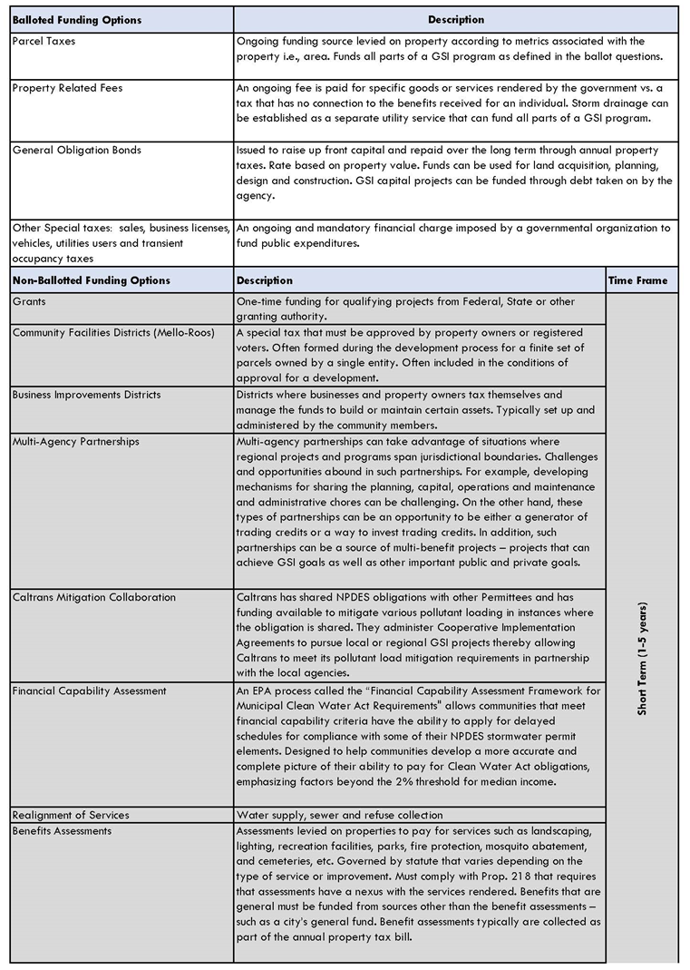
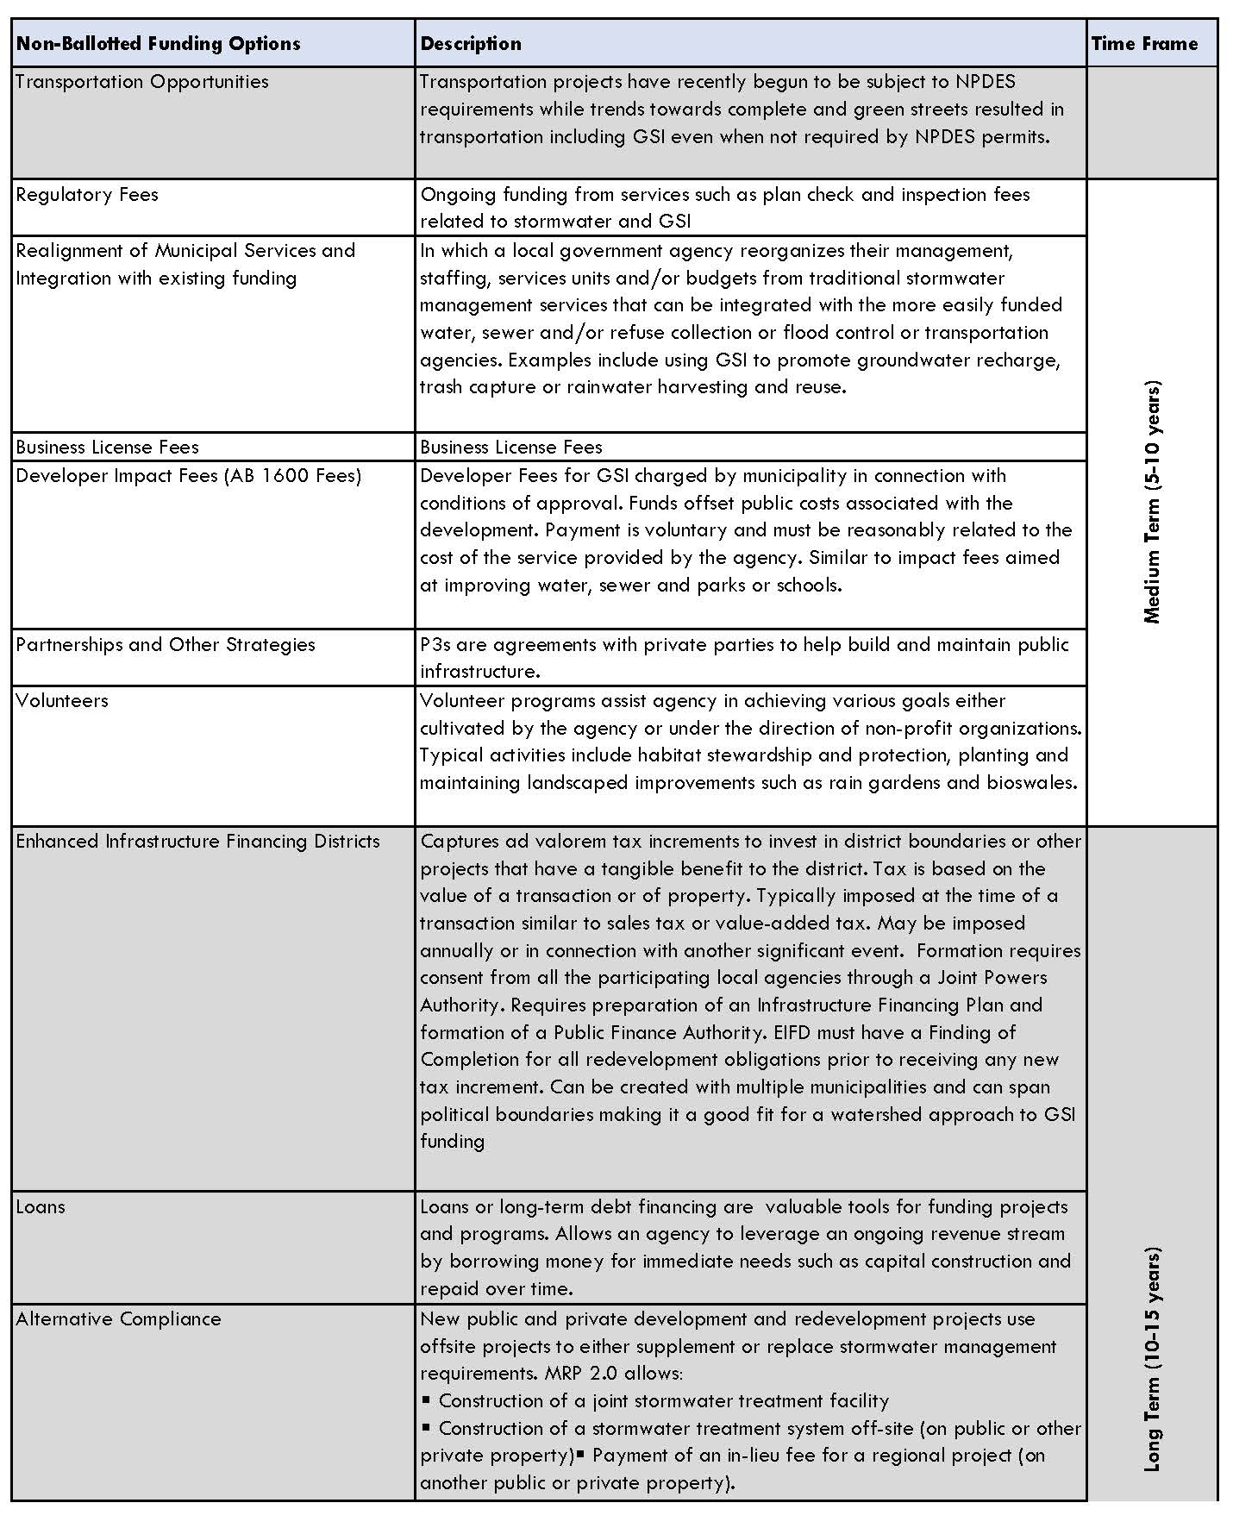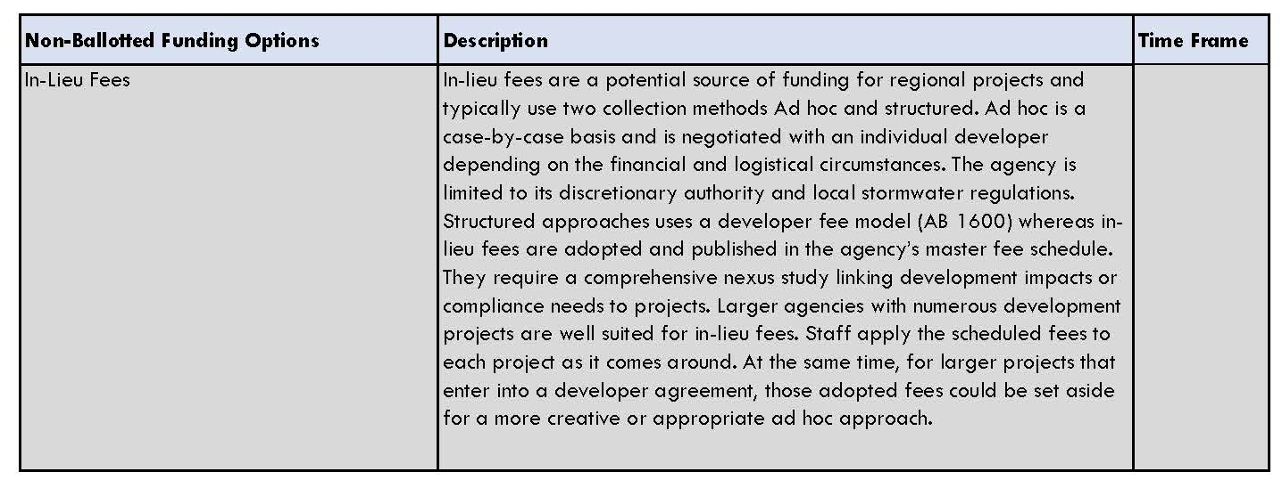

Appendix D – GSI Integration with City Plans and Documents
Document Review and Overall Assessment
As part of the development of the GSI Plan City documents were reviewed to determine if any changes were needed for the City to effectively implement the GSI Plan.
The City reviewed its other existing municipal planning documents and identified that none of these documents prevent the implementation of GSI projects within the City. Moreover, several planning documents already contain some language to support the GSI Plan. However, various plans need to be better aligned with the GSI Plan to require the integration of GSI and use of the various tools, specifications and guidelines addressed in this Plan and through subsequent implementation.
This Appendix includes recommended revisions to a sampling of the City’s planning and policy documents. These documents have been reviewed for updates to planning document content to support the implementation of green stormwater infrastructure per Provision C.3.j.i.(2)(h) of the MRP. This sampling provides a broad set of recommended update language that can also be used as a guide for the City to make updates to other planning and policy documents. The intent of making these revisions is to provide a policy framework that will support efficient planning, design, construction, and maintenance for green stormwater infrastructure.
The following is formatted with existing planning document text as normal styled text, deleted text is red with strikethrough and new text is red and underlined.
Vallejo General Plan 2040
p. 3-6, POLICY CP-1.6, Active Living
Active Transportation Network. Promote the health benefits of walking and bicycling by providing Complete Streets and Green Streets with a convenient and safe network of bicycle paths and routes, sidewalks, pedestrian paths, and trails, including connections with major destinations such as civic facilities, educational institutions, employment centers, shopping, and recreation areas.

p.3-6, Action CP-1.6A, Active Living
Identify problem locations in Vallejo regarding pedestrian/auto and bicycle/auto collisions, identify Complete Street and Green Street measures (e.g., traffic calming, improved street lighting) to reduce collisions, and develop a prioritized program for implementing identified measures.

p.3-6, Action CP-1.6D, Active Living
Develop Complete Street and Green Street guidelines for public and private projects that promote safe, convenient, and attractive bike and pedestrian facilities, including amenities to enhance bike and pedestrian activity, such as bicycle racks, lockers, street trees, public art, and street furniture.

p.3-7, POLICY CP-1.7, Urban Greening and Community Health
Green Space. Promote community physical and mental health through provision and preservation of the urban forest, natural areas, and green stormwater “green” infrastructure. (i.e. best practices water management).

p.3-7, Action CP-1.7E, Urban Greening and Community Health
Continue to implement green stormwater infrastructure practices, consistent with the City’s Green Stormwater Infrastructure Plan, that draw upon natural processes to address storm water drainage and flood control, achieve environmental benefits for stormwater quality, and potentially add to Vallejo’s network of green spaces.

p.3-9, Action CP-1.13D, Healthy Environment
Continue to provide information on water conservation best practices to residents and businesses in Vallejo, including information about green stormwater infrastructure strategies that can improve water quality and reduce the need to irrigate landscaping.

p.3-9, Action CP-1.13E, Healthy Environment
Support the efforts of federal, State, regional, and local agencies to clean up impaired water bodies in Vallejo, including opportunities for green stormwater infrastructure as identified in the City’s Green Stormwater Infrastructure Plan.

p.3-10, Action CP-1.15A, Healthy Environment
Require new development to incorporate green stormwater infrastructure, site design, source control, and treatment measures to keep pollutants out of stormwater during construction and operational phases, consistent with City of Vallejo Municipal Ordinance and the City’s Green Stormwater Infrastructure Plan.

p.3-17, NEW ACTION CP-3.4D, Parks as Gathering Places
Integrate green stormwater infrastructure into parks and open spaces, including tot lots, neighborhood parks, community parks, plazas/greens and/or greenways/parkway to assist in meeting goals for water quality and flood hazard reduction. For additional information see the City’s Green Stormwater Infrastructure Plan.

p.3-24, NEW ACTION CP-3.5D, Parks as Gathering Places
Green Stormwater Infrastructure Related Funding Opportunities. Identify potential to enhance funding of park maintenance using stormwater related funds when park improvements function as green stormwater infrastructure.

p. 4-4, NEW ACTION NBE 1.2F, Natural Resources
Use green stormwater infrastructure for improved water quality and stormwater management,
of open space, natural areas, watershed, and other lands. Refer to the City’s Green Stormwater Infrastructure Plan for guidelines and standards.

p.4-8, photo caption
Green infrastructure refers to the use of plants and soils to absorb stormwater and
filter pollutants before runoff is directed into the storm drain system. As a result, green
stormwater infrastructure reduces the capacity needed in pipes and reduces pollution levels in
stormwater runoff, offering cost savings and environmental benefits.

p.4-8, POLICY NBE-1.7, Urban Greening
Green Stormwater Infrastructure. Encourage the installation of green stormwater infrastructure, including tools such as permeable pervious pavement, rain gardens, constructed wetlands, grassy swales, rain barrels and cisterns, and green roofs, to treat stormwater, attenuate floods, increase groundwater recharge, and reduce urban heat islands.

p.4-8, NEW ACTION NBE 1.7B, Urban Greening
Implement the City’s Green Stormwater Infrastructure Plan as required by provisions of the Municipal Regional Stormwater NPDES Permit (MRP). Seek funding sources to complete
the identified capital improvements.

p.4-8, NEW ACTION NBE 1.8D, Urban Greening
Prioritize planting of trees in locations where they can maximize utility as green stormwater infrastructure.

p.4-12, Action NBE-1.14B, Resource Conservation
Continue to provide water customers with information on conservation techniques, services, devices, and rebates (including greywater reuse and rainwater harvesting), including online and through inperson community outreach.

p. 4-20, Action NBE-3.9C, Other Districts
Seek funding for Complete Streets and Green Streets to improve pedestrian and transit connections on Mare Island, including connections to the Mare Island Ferry Terminal.

p. 4-24, Action NBE-4.2D, Community Enhancing Uses
Install amenities such as playscapes, exercise equipment, picnic spaces, green stormwater infrastructure, and public art.

p. 4-25, Action NBE-4.3C, Access and Connectivity
Seek funding for green stormwater infrastructure improvements, landscaping, and outdoor amenities to increase pedestrian, bike, and transit access to the water and build linkages to downtown Vallejo.

p. 4-34, POLICY NBE-5.7, Flood Control
Design for Stormwater Control. Encourage new development and redevelopment to maximize use of green stormwater infrastructure and minimize the area of new roofs and paving.

p. 4-34, Action NBE-5.7A, Flood Control
Provide informational materials that promote the use of green stormwater infrastructure, including permeable materials for driveways, streets, parking lots, sidewalks, and plazas.

p. 4-24, Action NBE-5.7B, Flood Control
Continue to manage and maintain City-owned storm drainage and green stormwater infrastructure to avoid flooding and reduce the negative effects of stormwater runoff.

p. 5-20, Action EET-4.2A, Sustainable Development and Green Business
Continue to incorporate sustainable design elements such as solar panels, green stormwater infrastructure, and water efficient landscaping into the construction of City-owned and operated facilities.

p. 6-7, NEW ACTION MTC 1.5B, Trails
Encourage green stormwater infrastructure elements where park and trail improvements are made and conditions are appropriate. For additional information see the City’s Green Stormwater Infrastructure Plan.

p. 6-19, Action MTC-2.7A, Citywide Mobility

Investigate preparing and refining a Complete Streets map, classifying and prioritizing streets for alternative modes of transport and incorporation of green stormwater infrastructure.

p. 6-19, Action MTC-2.7B, Citywide Mobility
Seek funding to improve sidewalk conditions, including widening of substandard sidewalks and adding street trees, green stormwater infrastructure, and lighting.

p. 6-19, Action MTC-2.7C, Citywide Mobility
Establish City regulations to improve walking and biking opportunities in new development, including features such as sidewalks, signage, streetscape improvements, green stormwater infrastructure, bike lanes, and secured bicycle parking.

6-27, POLICY MTC-3.9, Downtown/Waterfront
Sufficient Parking. Provide for sufficient but not excessive parking that incorporates green stormwater infrastructure.

Downtown Vallejo Specific Plan
p. 3.2, Vision, Walkability
Traffic-calmed, pedestrian-scaled streets and public spaces that integrate green stormwater infrastructure, are landscaped with shade trees and attractive furnishings, lighting and fixtures define a pedestrian-friendly downtown.

p. 3.5, Vision, Vision for a Livable Downtown
Over a proposed ten to twenty year period, Vallejo's downtown seeks to accomplish the following:
• Mix land uses
• Promote compact building design
• Create a range of housing choices
• Create walkable neighborhoods
• Foster attractive buildings with a strong sense of place
• Promote inclusion of "green" building principles and green stormwater infrastructure

p.5.15, Urban Design, Sustainable Development
Sustainable design also incorporates site planning concepts that reduce the impacts of storm water on utility systems by limiting impervious surfaces and integrating green stormwater infrastructure; by reducing the negative impacts of excess light pollution; by integrating with alternative transportation resources, and by incorporating water efficient landscaping and building systems.

p. 7.6, Publie Services and Utilities, Stormwater/Drainage
2. While the Specific Plan would promote changes in land use, as well as development intensity /density, it is not envisioned that the changes in development will substantially change the amount or routing of runoff, in that a) Downtown Vallejo is fully developed and is largely covered by impervious surfaces; and b) the area is currently served by an adequate stormwater drainage system. Therefore, the Specific Plan will not necessitate the development of new or expanded stormwater drainage facilities or infrastructure for managing the quantity of stormwater runoff, however it presents an opportunity to incorporate green stormwater infrastructure as identified in the City’s Green Stormwater Infrastructure Plan.

3. The Specific Plan includes changes to the current public streetscape and associated infrastructure. However, these changes are not expected to significantly change the routing of stormwater runoff or impact system capacity. These changes are expected to provide opportunities for incorporating green stormwater infrastructure that will improve the quality of stormwater runoff and provide numerous other community benefits. Green stormwater infrastructure facilities will likely include underdrain and/or overflow structures connecting to the existing storm drain system.

p.9.6., Development Standards, Build-To Lines/Setbacks
• All setbacks facing the street shall be attractively landscaped and well maintained, and integrate green stormwater infrastructure where feasible.

p. 10.9. Implementation, Phasing of Public Improvements
Streetscape and Landscape Improvements: Streetscape and landscape improvements associated with these projects will include right-of-way improvements including landscaping, green stormwater infrastructure, green streets, street furniture, signage, public art, decorative paving, street lighting, street and pavement repairs prior to street overlay, street overlay, replacement curb, gutter and sidewalk, and surface storm drainage modifications in the public street rights-of-way immediately adjacent to or near the parcels.

p. D.1, Appendix D: Glossary of Terms
Complete Streets: Enable safe access for all users, including pedestrians, bicyclists, motorists and transit riders of all ages and abilities.

Green Streets: Use green stormwater infrastructure to capture, slow, and treat stormwater runoff.

Green Stormwater Infrastructure: A built approach to slow, infiltrate, use, and/or treat stormwater runoff using vegetation, soils, and natural processes to make stormwater runoff cleaner, absorb it back into the ground, and create healthier environments.

Downtown Vallejo Design Guidelines
p. 2.2, Public Realm, General Design Guidelines
2. Include green stormwater infrastructure to create tree-lined edges on both sides of the street
3. Incorporate traffic-calming elements using green stormwater infrastructure.

p. 2.8, Public Realm, Alleys
Lighting, pervious paving, signage, art and "greening" through green stormwater infrastructure landscape design are all possible elements that can bring alleys to life.

p. 2.9, Public Realm, Open Space and Landscape
The downtown street and alley network are also connective open spaces. Commonly considered only space for travel, the Design Guidelines recognize their contribution to enriching the experiential quality of downtown by enhancing the street with green stormwater infrastructure, through streetscape improvements, street trees, furnishings and lighting.

p. 2.15, Public Realm, Public Realm Design Elements
This section of the Design Guidelines will deal with specific descriptions and design intentions for the public realm in the Downtown. In order to provide and retain a higher quality of design, it is important to be prescriptive in how most of the pieces of the Downtown will be designed and what type of site furniture will be incorporated. The following section will describe typical conditions and improvements in the downtown as well as suggested quantities of site furniture where appropriate. For this purpose, a new type of subsection, Design Criteria, will be introduced to further explain details with information such as dimensions, materials, and colors. Bulb-outs, mid-block crossings, and tree islands should be designed as green stormwater infrastructure facilities consistent with the City’s Green Stormwater Infrastructure Plan.

p. 3.7, Site and Building Design, Parking
2. Design Landscaped, Pedestrian Oriented Parking Lots
On properties where surface parking is permitted, parking areas and lots should be located behind other street frontage uses, and oriented to the rear or interior of the property. Parking lots should not be located adjacent to public rights of-way. Planting and other landscape design Green stormwater infrastructure techniques should be used to screen parking from the view of any public streets.

p. 3.9, Site and Building Design, Open Space
Outdoor open space should be surrounded by active building uses, and include amenities and green stormwater infrastructure. landscaping.

p. 3.28, Site and Building Design, Green Buildings
3. Maximize Water Efficiency and Management
Install water efficient (low-flow) plumbing fixtures.
Reduce potable water consumption by collecting, storing and using site rainwater, stormwater or graywater for sewage conveyance and landscape irrigation.
Incorporate drought tolerant, native species landscaping to extend and enhance the green space and green stormwater infrastructure networks of the City.
Install green stormwater infrastructure roofs to increase evapotransporation, improve water quality, increase stormwater infiltration and reduce heat island effect.

Mare Island Specific Plan
p. 87., Landscape Design Guidelines and Standards
An important landscape design concept for Mare Island is to integrate green stormwater infrastructure and maintain and enhance significant existing rows and clusters of trees as a part of the new planting that will result from re-use development, as indicated in Figure 4-3 (Landscape Concept).
p. 89., Landscape Design Guidelines and Standards, New Landscape
Depending on the setting, required landscape may include, green stormwater infrastructure, street trees, planting along site boundaries and around buildings and parking facilities.

p. 90., Landscape Design Guidelines and Standards, New Landscape
vii. Use of drought tolerant plants, green stormwater infrastructure, and drip irrigation systems is are recommended.
….
x. Open spaces such as parks and greenways shall integrate green stormwater infrastructure and may be utilized for storm water detention during heavy storm periods.

p. 103, Urban Design Guidelines and Standards by Reuse Area, Community Park, Reuse Area 7
v. The park shall integrate green stormwater infrastructure elements and a portion of the park may be designed as a low-lying meadow providing seasonal storm detention.

p. 132, Proposed System Improvements, Storm Drainage System
All the proposed storm drainage improvements will integrate green stormwater infrastructure consistent with the City’s Green Stormwater Infrastructure Plan.

Climate Action Plan
p. 4-30, Reduction Strategy, E-4. Cool Roofs and Pavements
• E-4.3. Use green stormwater infrastructure to maintain and expand Vallejo's urban forest, including street trees and trees on private property.
• E-4.4. For public improvements and public projects, require the use of high albedo and pervious paving material for sidewalks, roads, crosswalks, parking lots, and driveways.

p. 4-61, Reduction Strategy, W-1. Water Conservation Efforts
W-1.1. Continue to provide water customers with information on conservation techniques, services, devices, and rebates by posting information at vallejowater.org or through other outreach methods. Provide educational materials to the community about green stormwater infrastructure strategies that can improve water quality and reduce need to irrigate landscape.
…
W.1.3. Retrofit and include new green infrastructure strategies into city-owned landscapes to improve water quality and reduce need to irrigate landscape.

Appendix E - GSI RAA Modeling Report

San Francisco Bay Regional Water Quality Control Board. 2015. Municipal Regional Stormwater Permit, Order No. R2-2015-0049. www.waterboards.ca.gov/sanfranciscobay/water_issues/programs/stormwater/Municipal/R2-2015-0049.pdf.
Although the MRP uses the term green infrastructure (GI), the Solano Permittees prefer to use the term green stormwater infrastructure (GSI). Henceforward, the term GSI will be used.
Permittees shall "quantitatively demonstrate that PCBs load reductions of at least 3 kg/yr will be realized by 2040 through implementation of green infrastructure projects" (C.12.c.ii.2.d) Percent of Solano Permittee load reduction is 20.8% PCBs and 16.1% mercury from BASMAA RAA Guidance Document (6/30/17).
The average wet weight concentration measured in the muscle tissue of fish large enough to be consumed by humans.
3-5 centimeters in length
average wet weight concentration
A roughly 50% decrease in sediment, fish tissue, and bird egg mercury concentrations is necessary for the Bay to meet water quality standards. Reductions in sediment mercury concentrations are assumed to result in a proportional reduction in the total amount of mercury in the system, which will result in the achievement of target fish tissue and bird egg concentrations.
This target is based on a cancer risk of one case per an exposed population of 100,000 for the 95th percentile San Francisco Bay Area sport and subsistence fisher consumer (32 g fish per day).
This value was developed based on applying the required sediment concentration (1 µg/kg) to the estimated annual sediment load discharged from local tributaries.
City of Vallejo, Vallejo Sanitation and Flood Control District, Fairfield-Suisun Urban Runoff Management Program, November 2016. “Task 5 Individual Retrofit Pilot Project: PG&E Substation Project”.
City of Vallejo, Vallejo Sanitation and Flood Control District, Fairfield-Suisun Urban Runoff Management Program, November 2016. “Task 5 Individual Retrofit Pilot Project: Broadway and Redwood Project”.
Vallejo Storm and Wastewater District, 2017. “Final Biennial Budget for Fiscal Years 2017-2018 and 2018-2019.
Solano County Water Agency, 2013. “Flood Awareness Manual”. http://www.scwa2.com/home/showdocument?id=24
2020 Reduction targets are fixed values specified in the MRP, 2040 Reduction targets have been rescaled based on new calculated baseline values per RAA Guidance Section 3.5 as a proportion of total estimated reductions (20.8% for PCBs, 16.1% for mercury)
BASMAA, June 30, 2017, Bay Area RAA Guidance Document
Percent of Solano Permittee load reduction is 20.8% PCBs and 16.1% mercury from BASMAA RAA Guidance Document (6/30/17).
The calculator follows the procedures from “Low Impact Development Stormwater Control Cost Estimation Analysis” (RTI International and Geosyntec Consultants, 2015).
The Regional Cost Adjustment Factor is determined from the Bureau of Labor Statistics Consumer Price Index and Producer Price Index for nationwide regions. The adjustment factor is computed for the three nearest regions to the project, with a value of 1.0 used when the three nearest regions are greater than 100 miles from the project. The San Francisco Bay area has a multiplier of 1.33.
Estimated based upon the PRISM rainfall, 4km raster dataset
BASMAA. 2018. Roadmap of Funding Solutions for Sustainable Streets. http://www.sfestuary.org/wp-content/uploads/2018/05/Roadmap_Funding_Solutions_Sustainable_Streets_FINAL_reduced.pdf. Prickett, L. September 4, 2018, Evaluation of Funding Options for Projects that Include Both Green Infrastructure and Transportation Improvements, Memo to the BASMAA Development Committee

